Chapter 2: Beetle assemblages in the Cederberg, and their changing environment

Introduction

Importance of insects
Insects provide a wide range of important ecosystem services globally, with pollination, natural pest control, decomposition, and ecosystem maintenance being only a few examples of the benefits that they provide (Kremen and Chaplin-Kramer, 2007; Oberhauser and Guiney, 2009). It is estimated that in the United States, insects provide approximately $60 billion worth of value annually when only considering a small subset of the ecosystem services they provide (Losey and Vaughan, 2006).
Beetles (Coleoptera) provide numerous ecosystem services that vary depending on their specific biological traits. Larger predatory and omnivorous families such as the Carabidae and the Cicindelidae regulate the populations of prey species, as well as engineering the environments around them by consuming the vegetative growths in the environment, potentially preventing any singular type of vegetation becoming dominant over others (Trichard et al., 2014; Makwela, Slotow and Munyai, 2023). Macrodetritivores such as tenebrionid beetles provide the key function of maintaining healthy levels of soil fertility and nutrient cycling through decomposing plant litter and other organic matter (Mordkovich and Afanas’ev, 1980). Species such as Nyctelia circumundata (Tenebrionidae) in Patagonia have been observed to be key in maintaining the trophic structures of the environments in which they are active (Cheli, Bosco and Flores, 2022).

Beetle assemblages, and factors influencing distribution
Beetles are one of the most diverse groups in the world with regards to both physiology and behaviour, therefore different groups of beetles will have their distributions affected by different factors (Liu et al., 2016). There are three beetle families of focus in this study: Tenebrionidae, Carabidae, and Cicindelidae. Tenebrionidae are mostly detritivores while Carabidae and Cicindelidae are mostly omnivorous predators (Scholtz and Holm, 1985; Picker, Griffiths and Weaving, 2019). Historically, Cicindelidae had been considered a subfamily of Carabidae, and the taxonomical status of whether they are two distinct families has long been debated, although it has recently reached a consensus where Cicindelidae were separated from Carabidae (Zhu et al., 2025). However, due to the previous grouping and their similar ecologies, past and current ecological studies still continue to examine them collectively as a unit in order to draw conclusions (Boutaud et al., 2022). Hereafter any references to Carabidae implicitly includes both Carabidae and Cicindelidae. When considering epigaeic beetle groups with limited or no flight capabilities, they are affected to a much greater degree by environmental changes to their immediate surrounding areas as their dispersal is limited, meaning that the effects of anthropogenic climate change will be exacerbated for them (Homburg et al., 2014; Duan et al., 2016). The three beetle families mentioned prior all exhibit limited flight capabilities (Lövei and Sunderland, 1996; Carpaneto and Fattorini, 2002). Whether or not a species is affected by an environmental factor, and to what extent it is affected, is mostly dependent on the interaction between its mobility and trophic strategy (Liu et al., 2016).
Various biotic and abiotic factors together determine beetle assemblage composition within their respective environments. These factors interact with the specific physiology and ecology of different insect species and determine whether or not those surroundings provide a suitable environment for them. This can either be due to environmental conditions that are not suitable for those species in question, or due to interspecific competition or predation by other animals present in the environment (Hodkinson, 2005).
All three prior mentioned beetle families have been shown to be affected by changes to vegetation and soil. For vegetation some of the key variables include ground cover, height, vertical complexity, biomass, and diversity all relative to their specific areas (Liu et al., 2016; Cheli et al., 2021; Gonçalves et al., 2021). For soil some of the key variables are: pH, texture, moisture, salinity, organic content, and conductivity (Holland and Luff, 2000; Duan et al., 2016; Cheli et al., 2021; Liu, Wang, Wang, et al., 2021). Temperature (air and ground temperature) was also shown to affect these families. For example, Carabidae were less affected by air temperature than ground temperature since they burrow to overwinter as larvae and adults (Lövei and Sunderland, 1996; Gonçalves et al., 2021). For Tenebrionidae both air and ground temperature can affect their distribution to a great extent (Santos, 2002; Cheli et al., 2021; Ren et al., 2025). Light intensity and light availability is related to vertical vegetative complexity but is still directly important for all of the families and are positively correlated with their distribution (Vodka and Cizek, 2013; Tyszecka, Zając and Kadej, 2025).
Precipitation is an important determining factor in the distribution of the Tenebrionidae and Carabidae. Tenebrionidae distribution is almost uniformly positively associated with non-extreme increased levels of precipitation (Liu et al., 2016; Cheli et al., 2021). There have been a number of recent studies that concluded that precipitation was the absolute greatest determining factor in the distribution of the predatory beetle families (Liu, Wang, He, et al., 2021; Liu, Wang, Wang, et al., 2021). However, there have been other studies that have shown the effects of precipitation on Carabidae are not uniformly positive for all species in arid environments, with different species being affected positively and negatively in the same study areas in response to changing precipitation (Tsafack et al., 2019). For Carabidae there are also a number of other factors that are specifically very effective at being a predictor for their distribution, such as abundance of prey, and interspecific competition with other predators (Niemelä, 1993; Lövei and Sunderland, 1996; Gonçalves et al., 2021).

Altitudinal interactions with assemblages and environmental factors
Covering an altitudinal gradient across a mountainous region is a very effective strategy when studying the ranges and environmental tolerances of various different types of organisms. This is because the altitudinal gradient allows for a wide range of environmental variables, vegetation composition, and the maximal and minimal limits of the species in question to those variables to be captured and analysed across relatively small spatial extents (Menéndez et al., 2014; Rutten et al., 2015). Different mountains will have completely unique histories involving specific environmental and geographical intricacies, changes in vegetation composition across the elevation gradient, as well as particular combinations of species interacting and forming assemblages. These factors all mean that mountains are usually biodiversity hotspots with high levels of endemism inhabited by a variety of specialist species (Soh et al., 2019; Musthafa et al., 2021). Mountains are also useful for conservation studies in this era of anthropogenic climate change because they allow for the importance of temperature for specific organisms to be studied observationally. Most mountainous environments exhibit a consistent inverse relationship between altitude and elevation (Röder et al., 2017; Vetaas, 2021). Any responses shown by insects towards temperature gradients across an altitude, could therefore be used as an analogue for climate change and increasing temperatures over time in a fixed location (Hodkinson, 2005; Bishop and Robertson, 2024). Studying how certain taxa are distributed and affected by the conditions across a mountain allows for a crucial basis in beginning a long-term observational project wherein the current and expected responses of local biodiversity can be continuously monitored (Botes et al., 2006; Bishop and Robertson, 2024).
Studying beetle distributions across an elevational gradient can allow for the reactions of key species to environmental variables (temperature, precipitation, and vegetation) to be confirmed and/or quantified. For example, the predicted response of many ectotherms such as insects towards increasing temperatures is an expansion of their maximal altitudinal range (Wilson et al., 2005). It is expected that higher elevation environments might have been previously unsuitable for habitation by the taxa in question due to the temperatures being below their minimal thermal limits (Wilson et al., 2005; Menéndez et al., 2014). However not every group will react in this specific way.
An upwards shift in distribution has been observed in Geometer moths (Geometridae) on a tropical mountain in Malaysia (Chen et al., 2011). Various dung beetle species have also shown up-slope range shifts that were attributed to increasing temperatures (Menéndez et al., 2014). Vegetation is also affected by the environmental gradients present across a mountain, with a majority of vegetation having shifted upward in their elevational range over the last century due to climate change (Lenoir et al., 2008). However, recent studies have shown that as global temperature have increased, other factors such as changing precipitation regimes and intensifying wind speeds have also meant that some plants are also shifting downwards in their range (Zu et al., 2023). Due to high levels of specialisation shown on mountain ecosystems, there are quite a number of beetle taxa, most commonly herbivorous species, that have a dependent relationship on specific host plants for their food and habitat. Those species have altitudinal ranges that are closely tied to their host plants and will usually shift in response to changes in the plant’s distribution rather than other environmental variables (Hodkinson, 2005). Certain insects might rely on host plants through tolerating the ambient temperature of their environments by using the microclimate it provides in areas they otherwise would not be able to inhabit (McCain and Garfinkel, 2021).

Environmental changes
Climate change is one of the most prevalent causes behind the mass decline in entomofauna abundance and biodiversity that is being observed globally (Forister, Pelton and Black, 2019; Sánchez-Bayo and Wyckhuys, 2019; Harvey et al., 2023). The most recent IPCC Synthesis Report discussed that immediate interventions were necessary to reduce greenhouse gas emissions in order to meet what was previously considered a worst case scenario of a 1.5°C global temperature increase, and avoid the now projected 2°C global temperature increase projected for 2050 (Calvin et al., 2023).
Insect populations will have various responses to the effects of long-term anthropogenic climate change. The baseline increase of mean global temperatures will mean that a number of different taxa living in specific environments will gradually experience their suitable ranges shrinking due to other areas increasingly being above their critical thermal limits. Associated changes in other important factors such as host vegetation availability and soil moisture reduction, will result in less habitable space for most insects, and will usually result in mass mortality for many populations (Harvey et al., 2023). The extent of the loss in insect distribution, biodiversity, and abundance all depends on how far the effects of climate change progress in the coming decades. Scientists have stated the importance of insects in ecosystems globally with respect to the ecosystem services they provide. Many of those insects are declining in abundance and many have already become extinct, with an estimated 70% reduction in flying insect abundance over the last 30 years, and 60% reduction in large Carabidae in the United Kingdom over a 15-year period (Brooks et al., 2012; Cardoso et al., 2020).
In Southern Africa, the effects of increasing global temperatures are expected to be droughts, increased heatwaves, extreme loss of soil moisture, with all of these factors contributing to more frequent and intense fires throughout the region (Midgley et al., 2003; Hannah et al., 2005). This general drying of the environment is expected to affect biomes that experience Winter rainfall as well as Summer rainfall (Harvey et al., 2023; Munday et al., 2025; Sharp et al., 2025). The effects of climate change are also expected to cause disruptive climatic phenomena such as the El Niño Southern Oscillation (ENSO) to increase in frequency as well as intensity (Wang et al., 2019). These changes in the expected behaviour of the ENSO has been suggested to be strongly linked to anthropogenic greenhouse gas emissions (Cai et al., 2023). ENSO also confounds with observations made to record the baseline climate, providng an additional layer of difficulty in analysing the extent of climate change and its potential effects in respective areas. This means that more frequent and intense ENSO events will also make future monitoring for conservation priority guidance more difficult (Samways, 2010).

Background and Aims
A time series analysis was conducted in October of each year from 2002 to 2005 across an altitudinal gradient in the Cederberg Mountains of the northern Cape Floristic Region (Botes et al., 2006; Botes, McGeoch and Chown, 2007). During this period they sampled the epigaeic insects found within that transect using pitfall traps. This study was repeated after 20 years, utilising the exact same sites and sampling configuration. Various environmental and climatic factors such as proportionate ground cover, vegetation heights, continuous temperature readings, and soil samples, were collected and compared to historical environmental data that was collected during the original study (Botes et al., 2006). This was done to understand how the environmental conditions in this transect have changed over the previous 20 years. Through comparing and analysing the data from both time periods it was determined if any of the identified species had changed in abundance or distribution. Beetles from recent sampling (2022-2024) were compared between vegetation types, while three beetle species (Anthia decemguttata, Stenocara dentata, and Zophosis gracilicornis) were compared to historical sampling.
I hypothesised that will be an increase in the abundance of beetles at higher altitude sites compared to the historical study, due to the expected increased mean temperature across the entire transect (Wilson et al., 2005).

Methods

Site and sampling
The methodology and sampling configurations involved in the design of this study are identical to those used in a historical study started in 2002 (Botes et al., 2006). This study was conducted in the Greater Cederberg Biodiversity Corridor, specifically across an altitudinal transect that spans both aspects (East and West) of the Cederberg mountains. This altitudinal transect comprises the major vegetation types found within the Cederberg Wilderness Area, being Strandveld Succulent Karoo, Mountain Fynbos, and Succulent Karoo (Mucina and Rutherford, 2006), therefore representing almost the full range of vegetation that could be expectedly observed in this region.
A total of 17 different sites were sampled with 200 metre altitudinal intervals between each, ranging from sea level at Lambert’s Bay on the western aspect of the transect (sea level, Strandveld Succulent Karoo), to Sneeukop (1926 metres a.s.l.), and continuing down the eastern aspect of the mountain and ending near the town of Wupperthal (Lowland Succulent Karoo, 500 metres a.s.l.) (Figure 1). All of the sites between the two endpoints of the transect were considered to be representatives of Mountain Fynbos vegetation. These Mountain Fynbos sites were categorised as Restioid, Ericaceous, and Proteoid according to the respective dominant vegetation family found within that environment (Botes et al., 2006).
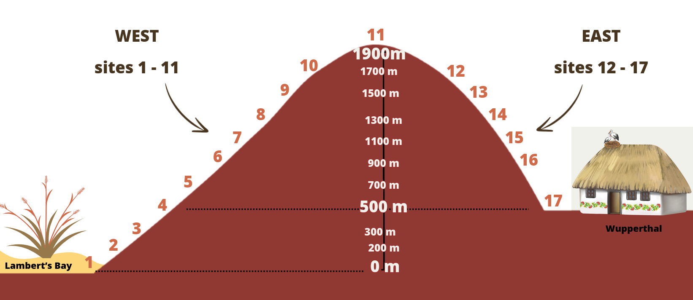
Figure 1 Diagram representing the study transect.

Pitfall traps were used to sample epigaeic insects across the transect. At each of the 17 sites four areas were chosen as replicates, with each replicate being at least 300 metres away from any of the other replicates. At each of these replicates ten pitfall traps were buried in the soil in such a way that the rim of the pitfall trap was level with the ground. The present vegetation was not cleared away when placing the pitfall traps and disturbance of the surrounding areas was kept minimal. Each of the ten pitfall traps were placed in a grid made up of two rows containing five traps, with each trap being at least 10 metres away from any other trap (Figure 2). GPS coordinates were recorded for every trap for use with spatial analyses later. The traps were half-filled with a 99.9% propylene glycol solution and were left out for five nights before being collected. This insect sampling was performed every October and March starting from October 2022 and ending in March 2024. For this study, the October 2022 samples were used. In the historical study, beetles were sampled in October 2002 and October 2003.
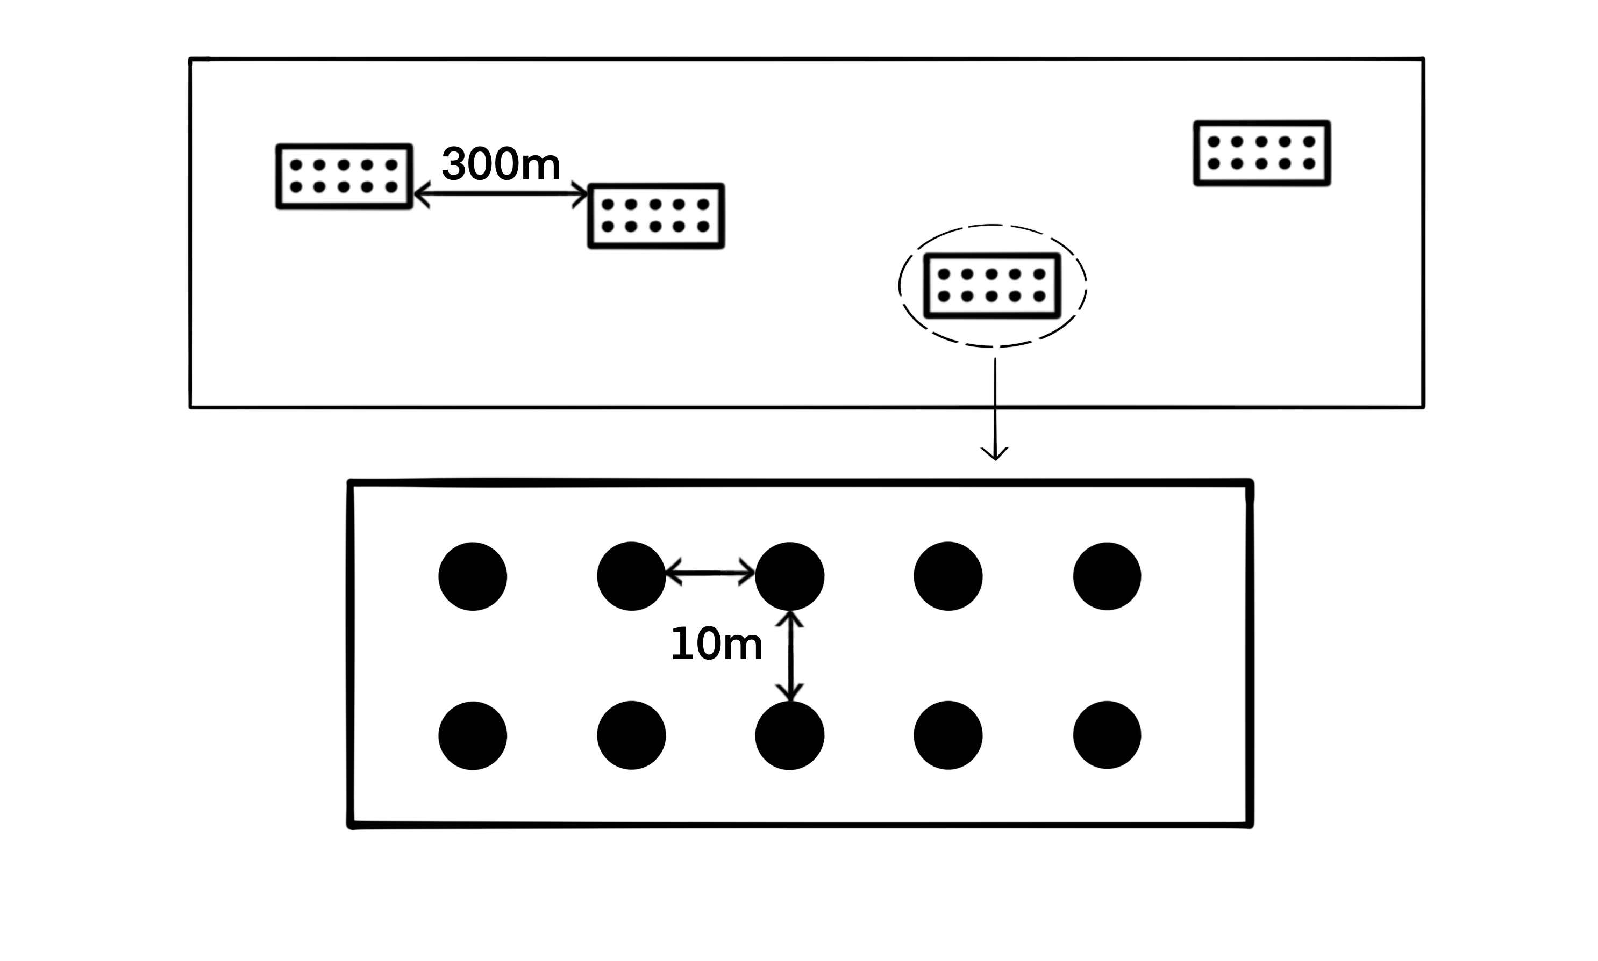
Figure 2 Sampling configuration (adapted from Botes et al., 2006).
During October 2002 and 2022, a 20cm³ soil sample was collected in each replicate and were analysed in order to determine and quantify the proportional composition, mineral contents, ionic contents, pH, and conductivity. These samples were collected by first taking 20 sub-samples of soil randomly across the grid of traps, then these sub-samples were mixed together, and the final sample was taken from this mixture. After the soil samples were air-dried in the laboratory for 10 days, they were sent in to be analysed for the mentioned characteristics by BemLab (Pty Ltd.), Strand, South Africa.
Vegetation was sampled in two different ways at each trap in order to determine both horizontal and vertical distribution of the vegetation. The ground cover of vegetation distribution was determined by placing a 1-m² quadrat down with the pitfall roughly at the centre. Following that, the percentage of the ground that was covered by the four classifications of leaf litter, live vegetation, exposed rock, and bare ground were estimated. After estimating the ground cover, a 1.5 metre long rod was placed at each corner of the quadrat. This rod was marked at 25 cm increments and the number of times vegetation made contact with the rod within each height interval was recorded. These counts of contact were used to determine foliage height profiles surrounding each trap.
In the laboratory, beetles were identified to morphospecies. The identifications were performed through assigning the observed beetles to morphospecies (Barratt et al., 2003). Each beetle was either pinned or mounted depending on its size, and they were then labelled and grouped by sample. The 2022-2023 beetles were identified by a taxonomic expert (Werner Strumpher, Ditsong Museum). Only the beetles belonging to the Tenebrionidae, Carabidae, and Cicindelidae families were identified further than family level and used for all analyses comparing the historical samples to the current data, as these are the same three families that were analysed in the historical study (Botes, McGeoch and Chown, 2007). Three key beetle species—the carabid Anthia decemguttata (previously Thermophilum decemguttatum), and the tenebrionids Stenocara dentata, and Zophosis gracilicornis—were determined to be the three most abundant and widespread beetle species present across the transect in the current and historical studies. These three species in particular were used for historical comparisons, and for the October 2023 sample these were the only beetle species identified out of all of the beetle species sampled.

Climate modelling and environmental data
Soil temperatures across the transects were measured hourly over the 20-year duration of this study using iButton sensors (Semiconductor Corporation, Dallas/Maxim, TX, USA). Temperature observations were halted for a protracted duration from late 2020 to 2022. Therefore, a mechanistic model was utilised in order to model the microclimate temperatures present.
The “micropoint” model was used to model the ground-level soil temperatures present within the sampling area (Maclean, 2025). This mechanistic model required the input of the meteorological data of the locations to be modelled, as well as defining parameters that correspond to the vegetation, soil, and ground in those areas.
Spatial meteorological data were obtained using the MCERA5 package in R (Klinges et al., 2022), which is based on the ERA5 global climate reanalysis (Hersbach et al., 2020). Using the GPS co-ordinates of each replicate at every altitudinal site across the transect, hourly observations from 2002 to 2024 were extracted for every sampling replicate. The climate variables of air temperature, relative humidity, atmospheric pressure, shortwave radiation, longwave radiation, diffuse radiation, wind speed, wind direction, and precipitation were used in order to run the microclimate model (Maclean, 2025).
Soil was analysed at each sampling site for their proportional composition of silt, clay, sand, and stone. These compositional measurements were used to group the soil at each site into different categories. These classifications were utilised to apply the corresponding pre-set soil parameters for model creation provided by the micropoint package. The parameters necessary for the model were ground reflectance, ground emissivity, soil bulk density, volumetric mineral fraction of soil, volumetric quartz fraction of soil, mass fraction of clay, a Shape parameter for Campbell soil moisture models, matric potential of soil, volumetric water content of soil at saturation, residual water content of soil, a shape parameter of the van Genuchten model, pore size distribution parameter for the soil, and the saturated hydraulic conductivity of the soil (Maclean, 2025). Other required ground parameters of slope and aspect were determined using the NASA SRTM digital elevation model (NASA JPL, 2013).
The vegetation parameters required for the microclimate model were determined using the average vegetation cover and vegetation height that were measured at each pitfall trap, averaged across replicates. These measurements were utilised to generate the required parameters of canopy height, plant area index, leaf inclination angle, canopy clumping, leaf reluctance of shortwave radiation, leaf transmittance of shortwave radiation, the diameter of leaves averaged over both the length and width of leaves, emissivity of vegetation, maximum stomatal conductance, and stomatal sensitivity (Maclean, 2025). Using all of the required data and generated parameters, the hourly microclimate temperatures at both the soil level and 0.5cm above the ground were calculated using the micropoint model. These modelled temperatures were compared graphically to the empirical temperature observations of both the iButtons and the meteorological temperature observations. The meteorological data were also utilised to extract the hourly precipitation over time per replicate along with the temperature modelling. All of these data were extracted and analysed using R and the “MCERA5” package (Klinges et al., 2022).
Utilising the CapeNature database , a list of historical fires that had occurred within the bounds of the study area were compiled. The extent of each fire and its date were stored using spatial polygons through the “sf” package in R (Pebesma and Bivand, 2023). The fires were attributed to each pitfall trap using the GPS co-ordinates of the trap. Through cross-referencing the site co-ordinates and the extent of the polygons, a map and database was created which showed the list of all of the fires a particular site had experienced in recorded history, as well as the most recent fire, and consequently the years since the last fire. These fire data were used in conjunction with the other environmental data in order to provide a further explanatory variable to explain the environmental changes that were observed.

Statistical analyses
All data analyses, except for the calculation of slope and aspect based on GPS co-ordinates, were performed in R (R Core Team, 2026). For the October 2022 and March 2023 samples, all of the beetles were compared to each other visually using bar charts and Non-metric Multidimensional Scaling (NMDS) plots. The abundance and species richness between the two seasons were also compared quantitatively, across the entire transect and on a site-by-site basis. The three key species were used to compare the current beetle samples (October 2022, October 2023, and March 2023) to the historical beetle samples (October 2002 and 2003) in terms of abundance. Although diversity could not be compared directly between the current sample and the historical sample, species density could be used as a comparison as it does not rely on the same species to be matched or identified in the different samples.
Redundancy analysis (RDA) was used to examine the relationships between the beetle sampling and assemblage structure with the environmental variables. RDA was performed on the historical beetle comparisons, the current seasonal comparisons, as well as the October 2022 sampling season. For the current samples where all of the species from the three families of interest were identified, both the abundances, and the presence-absence data of the beetles were analysed with RDA.
The results of the significant variables obtained from the RDA, as well as prior known explanatory factors that affect beetle abundance and diversity, were used to construct generalised linear models (GLMs) in order to quantify the effects that these various factors may have on the beetle assemblages. Specifically, due to the sampling being repeated on the same locations across a temporal gradient, Generalised Linear mixed-Effects Models (GLMMs) were used (Bates et al., 2015).
Whether or not beetle species were shifting in their altitudinal range were analysed. The data were compared both using all of the species compared between the contemporary beetle samples, as well as the three key species compared between the contemporary samples and the historical samples. The Jaccardian similarities of the different sites compared between the current and historical sampling efforts were computed to show the differences in beetle assemblage composition within each site across the 20-year gap between sampling.
The environmental variables of vegetation ground cover, vegetation height, and soil attributes, were also compared across the various temporal categories corresponding to the different beetle sampling events. They were compared to determine whether the environment surrounding the sampling sites had changed significantly between the different sampling efforts. The changes in environmental conditions combined with the effects that those variables have on beetle assemblage responses as shown in the GLMs will be used to determine whether or not those changes could be driving reasons behind the population changes. The fire data were used to determine whether or not there was a relationship between the recorded fire and the environmental variables present within the sampling sites.
The time-series data for the modelled microclimate temperatures (air and ground) as well as the precipitation observations were analysed using Seasonal-Trend Decomposition with Regression (STR) (Dokumentov and Hyndman, 2022). The STR models separate the changes in the response variable into parts of cycling seasonality (daily, yearly, etc.), and trend over time. This allows for baseline trends in the time-series data to be extracted and determine if there are any potential observable directional changes over time. After determining any potential trends per site, descriptive representatives of the relevant variables can also be incorporated in the interpretation of assemblage changes over time and also utilised in any models.

Results

Environmental variables analysis
The proportional composition of ground cover was observed to have changed significantly between the historical and contemporary sampling events. There has been a general trend where the proportion of the bare ground and exposed rock has decreased, while the proportion of plant litter and live vegetation cover have all proportionally increased (Figure 3).
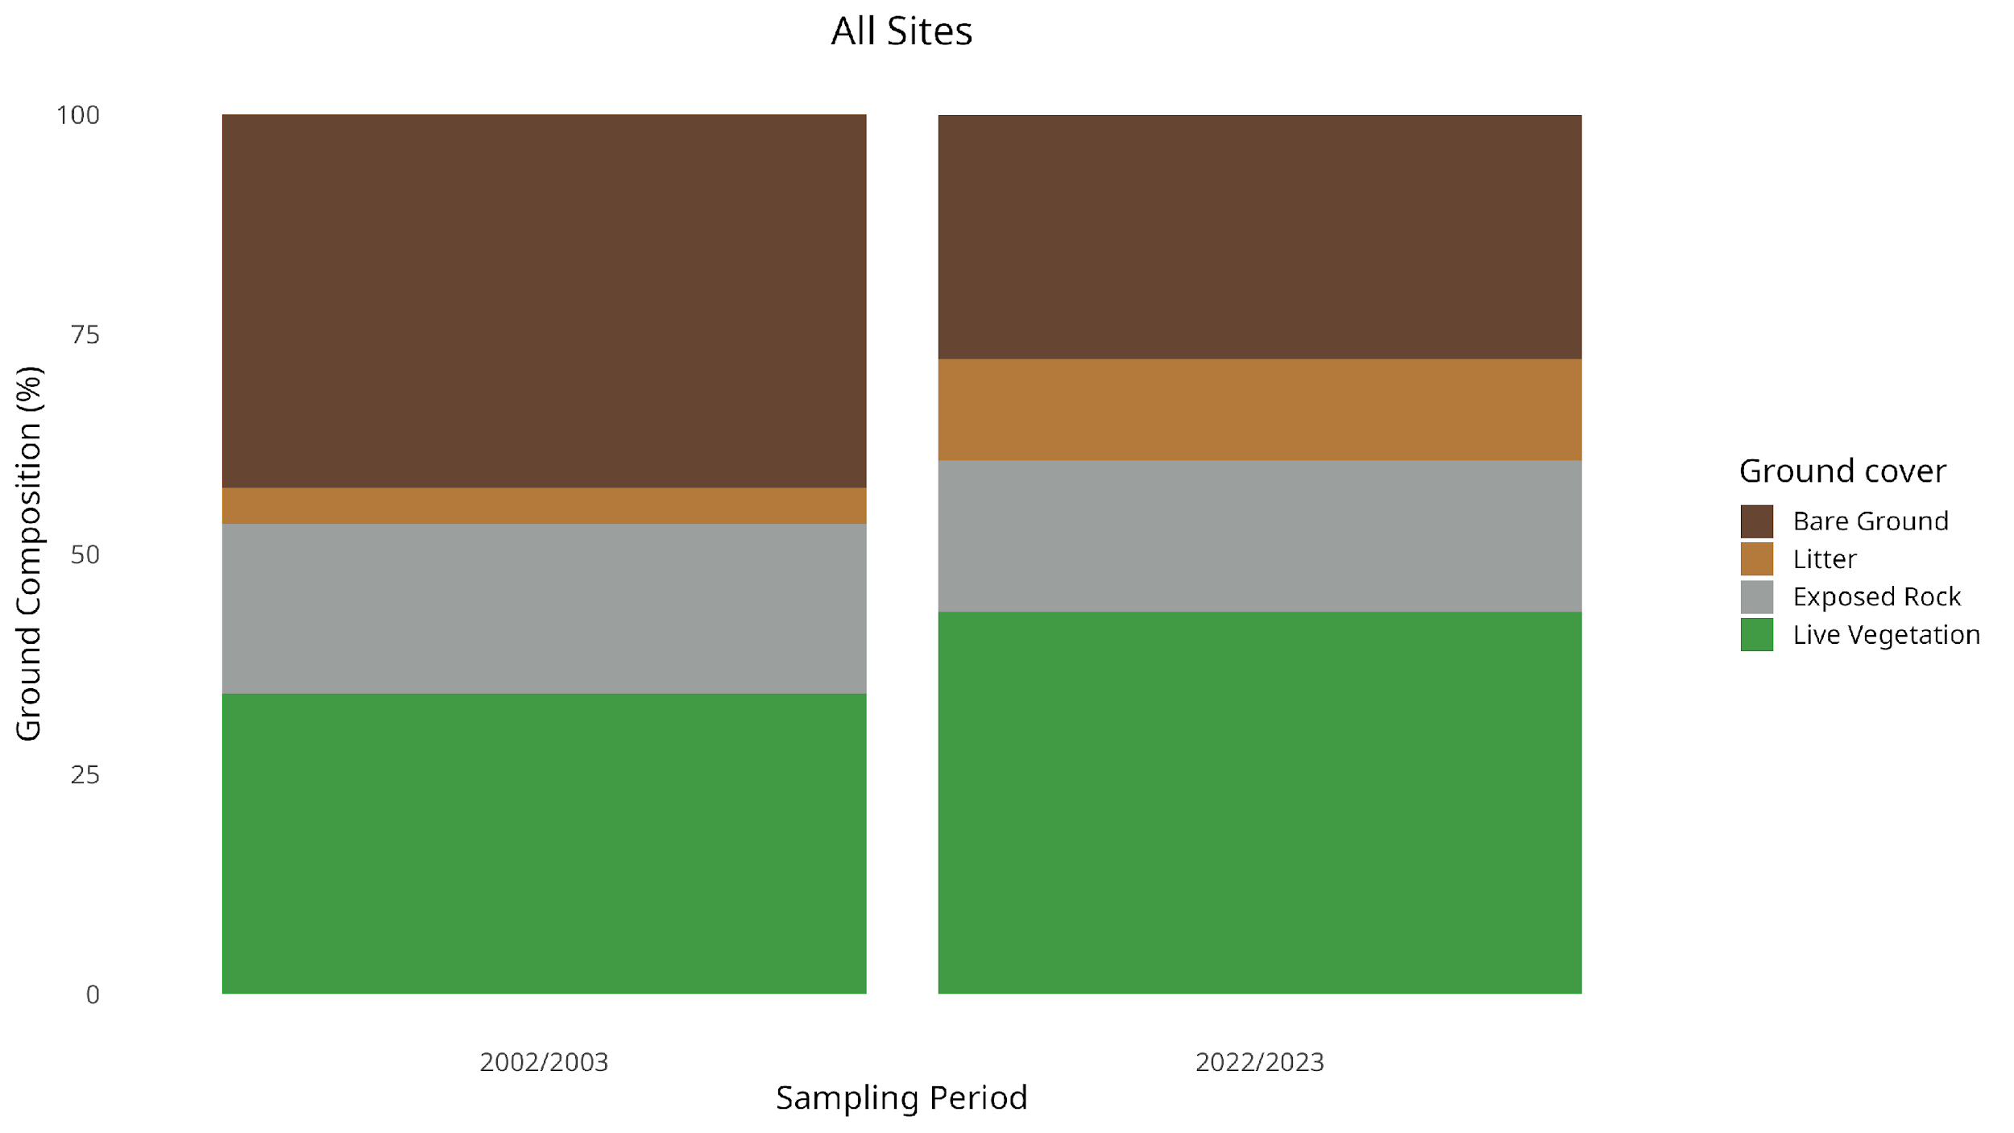
Figure 3 Mean proportional composition of the ground cover present across the entire transect, compared between the two different sampling periods.

When these data were analysed with the GLMMs, all of these changes in proportional composition were determined to be significant. Across the time that has passed between the two sampling periods, bare ground has decreased by 35% (43% in 2002–2003, 28% in 2022–2023), plant litter has increased by 183% (4.1% in 2002–2003, 12% in 2022–2023), exposed rock has decreased by 10% (19% in 2002–2003, 17% in 2022–2023), and live vegetation cover has increased by 27% (34% in 2002–2003, 43% in 2022–2023), across the entire transect (Table B).
Vegetation height has changed significantly over time across the entire transect, with both the mean vertical complexity of vegetation and the mean maximum vegetation height increasing in the time between the sampling periods (Figure 4). When analysed with GLMMs these changes were determined to be significant, with mean vertical complexity of vegetation increasing by 28% (8.41 in 2002–2003, 10.7 in 2022–2023), and mean maximum vegetation height increasing by 54% (29 cm in 2002–2003, 58 cm in 2022–2023) (Table C). The changes in these vegetation height characteristics were site-specific, and further GLMM analysis including site as an explanatory variable showed in which sites there were significant changes. In every site where there was a significant change, the direction was increasing over time as suggested when considering the transect as a whole (Appendix S8).

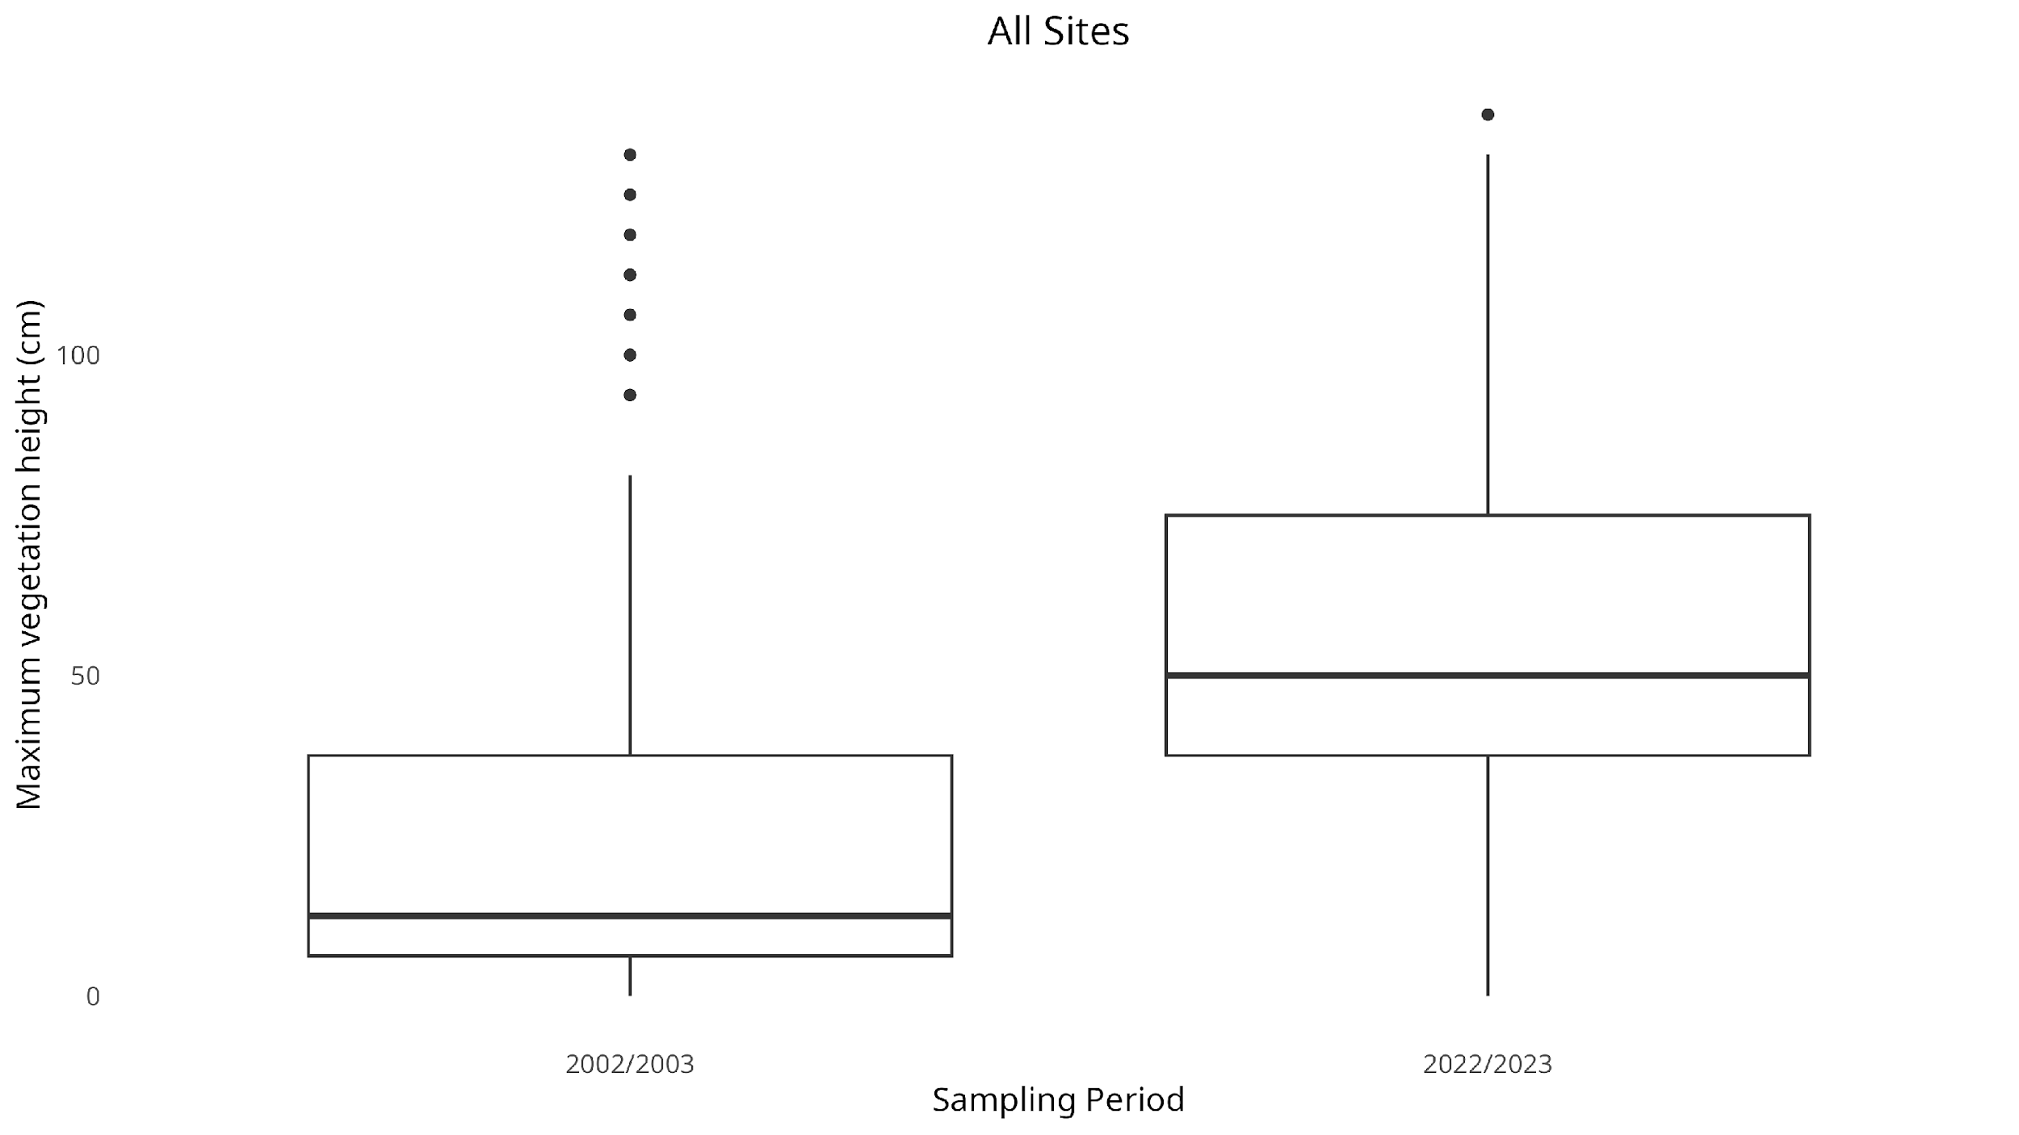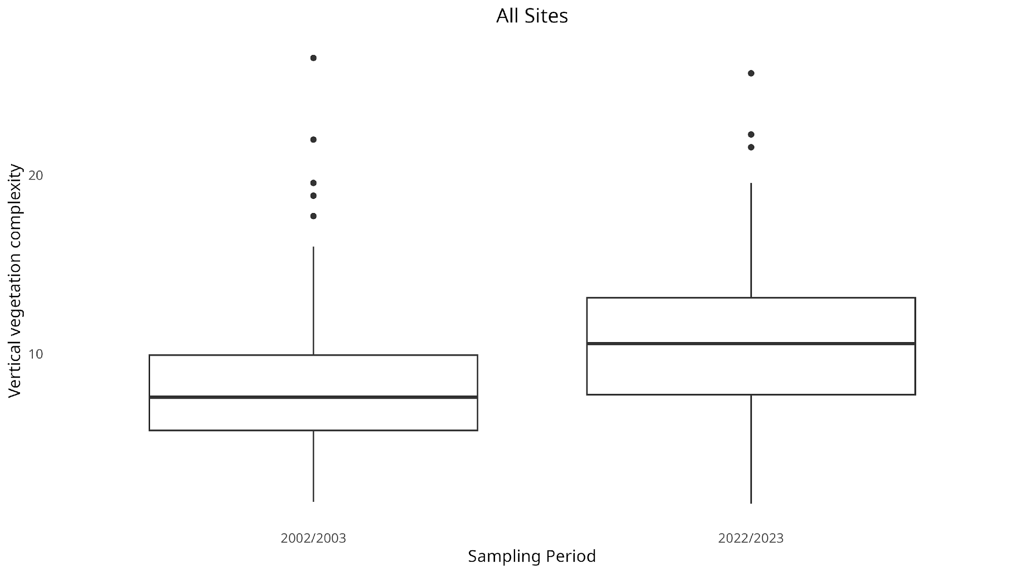Figure 4 The (a) vertical vegetation complexity, and (b) mean maximum vegetation height, across the entire transect compared between the different sampling periods.
(a)
(b)

Temperature and precipitation seasonal decomposition
The comparisons between the iButton senor data and the modelled microclimate data showed that the temperatures were matching overall and were there valid replacements for the empirical temperature observations and the missing gaps of temperature monitoring contained therein (Appendix MP1)
The STR models generated for each individual site were examined to see if their trend components contained any noticeable change over time. There was general increase in both air and ground temperatures across the entire transect over time (Figure 5). Keeping seasonal fluctuations and climactic phenomena in mind, there has been a 0.19°C (t = 878.289, P < 2e-16) and 0.23°C (t = 727.2, P < 2e-16) increase in the baseline air and ground temperatures respectively.
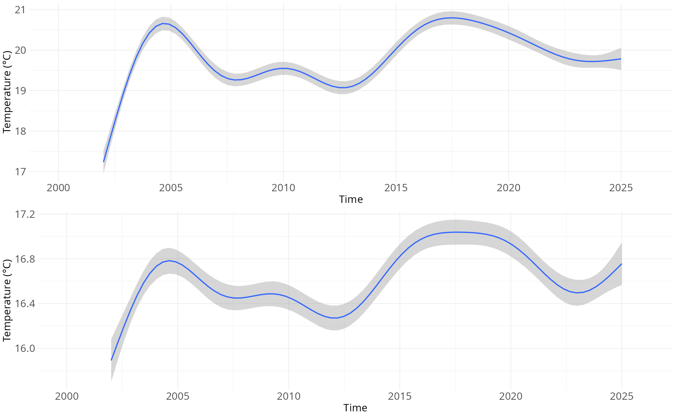
Figure 5 Temperature trend over time for (a) ground temperature, and (b) air temperature across the entire transect.

Some of the sites exhibited a visibly monotonic temperature trend over time, for example the site at 700 metre altitude on the western slope (Figure 6). This temperature trend was quantified at an estimated 0.84°C (t = 210.8, P < 2e-16) increase in ground temperature, and a 0.19°C (t = 1231.212, P < 2e-16) increase in air temperature over the 23 year period. A total of 8 sites across the transect showed this trend of monotonic baseline temperature increase over time (Appendix S4): "500m(W)", "700m(W)", "1100m(W)", "1300m(W)", "1700m(E)", "1300m(E)", "900m(E)", and "500m(E)".
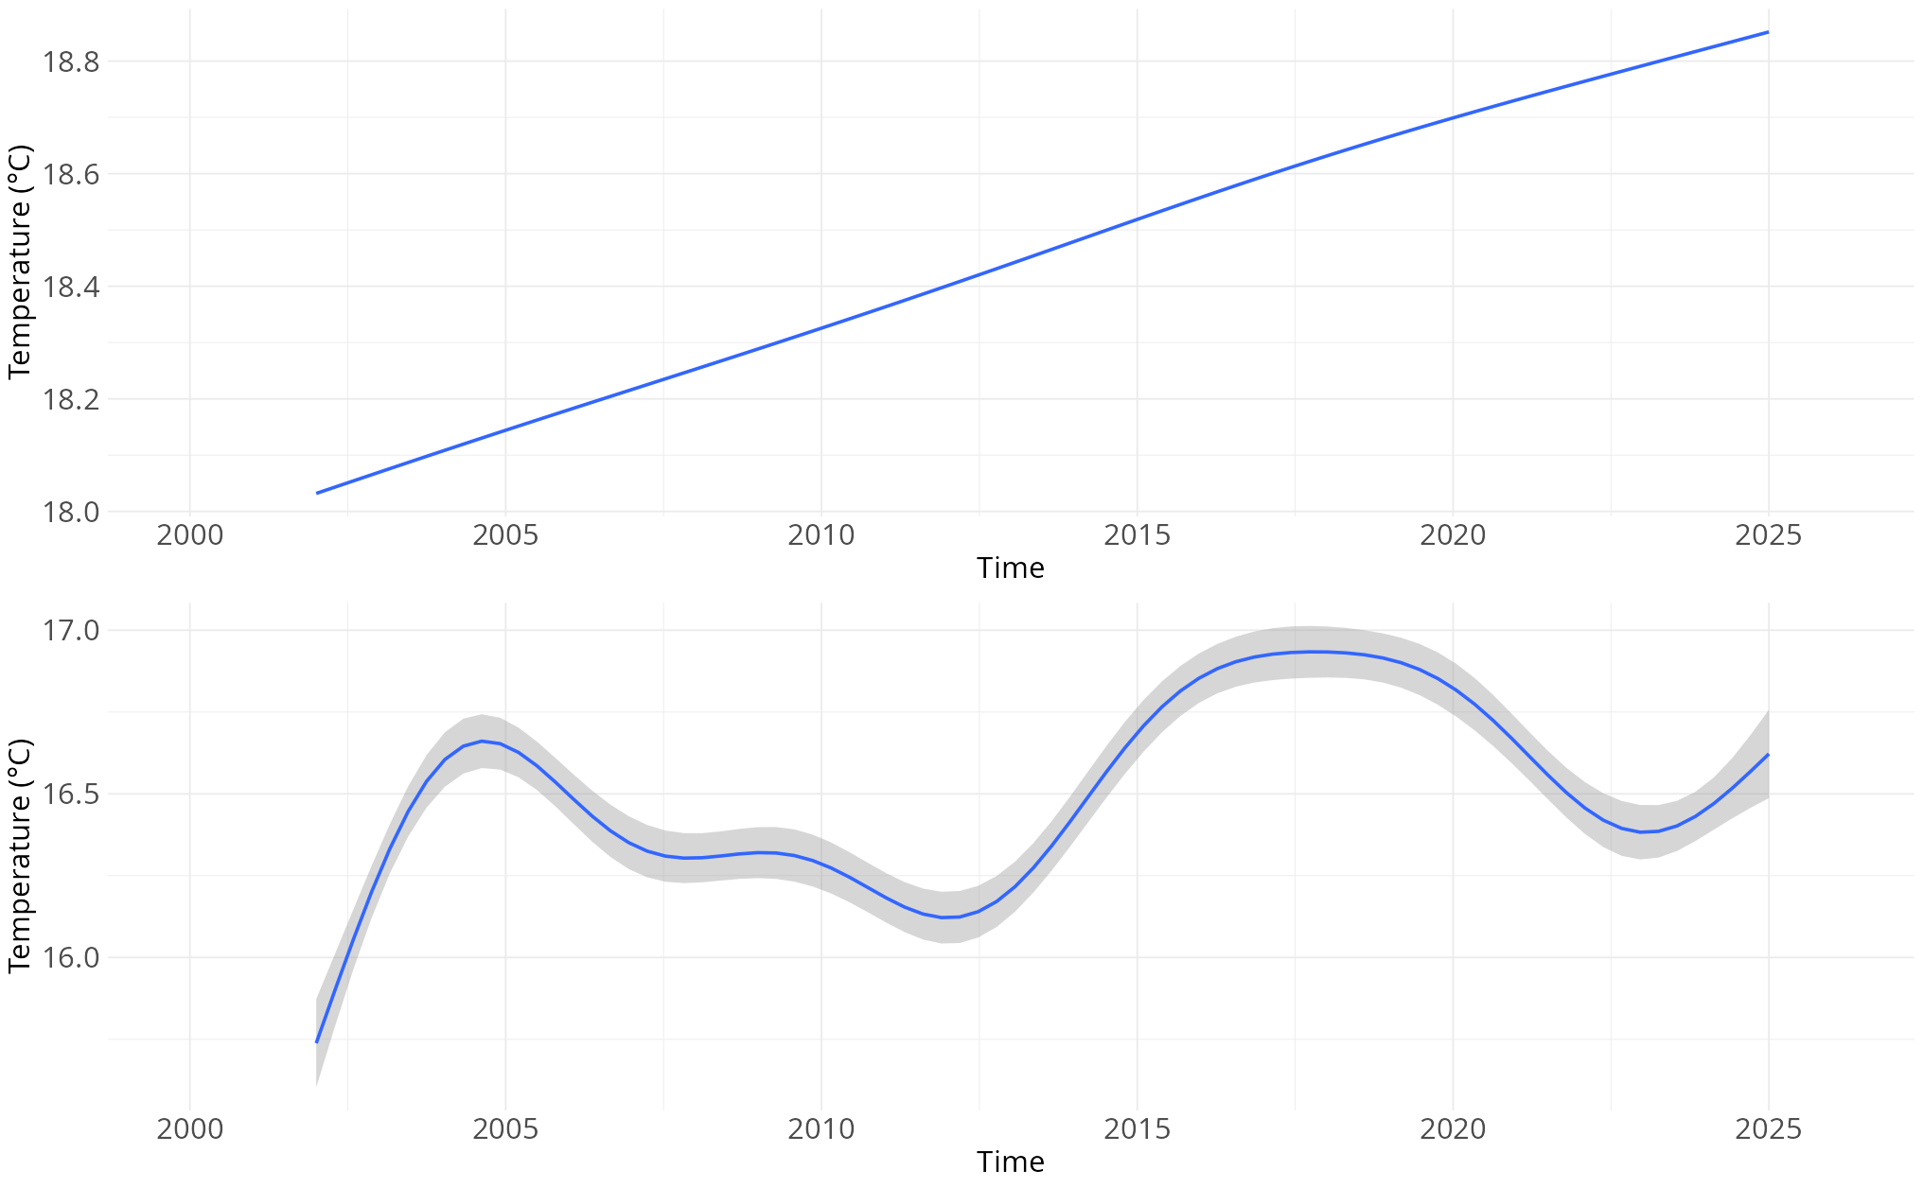
Figure 6 Temperature trend over time for (a) ground temperature, and (b) air temperature for the site at 700m altitude on the western slope.

There was a consistent change over time, even in sites where the baseline temperature did not display a trend, of the cyclical seasonality of air temperature becoming increasingly more extreme in terms of both local temperature minima and maxima (Figure O). This general observation both across the entire transect and within each individual site, with varying degrees of increased extremity in the seasonality (Appendix S5).
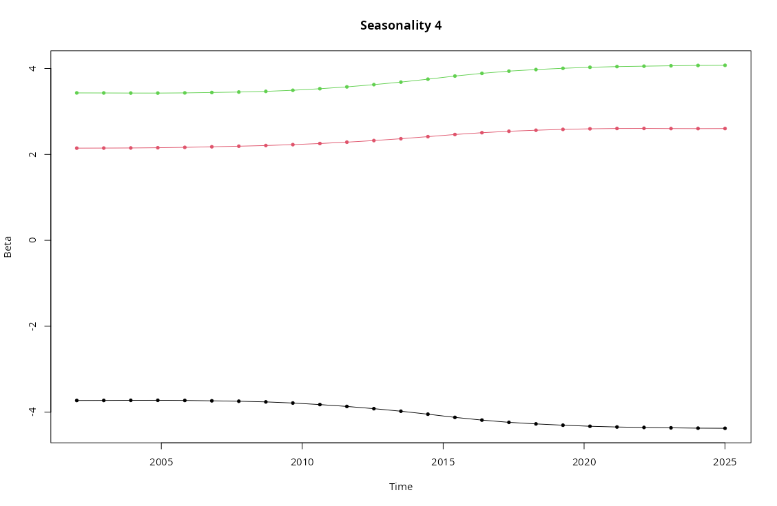
Figure O Seasonality of air temperature for the entire transect, showing the change over years of the coldest time of the day (bottom black line), hottest time of the day (top green line), and the middle of the day (middle red line).

The seasonal decomposition plots for precipitation did not show any monotonic changes in the precipitation trend over time for any particular sites. However there was an overall cyclical trend change where there have been multiple peaks and troughs of baseline precipitation over the years (Figure Pa). Most of the variation in precipitation is observed in the first five sites of the transect ("0m(W)", "200m(W)", "300m(W)", "500m(W)", "700m(W)"), with the remaining twelve sites having an almost identical precipitation history across the history of the study (Appendix S6). Despite there not being a monotonic change in the baseline trend, there was a consistent change in the cyclical seasonality of precipitation, exhibiting steady increases in both the minimum and maximum precipitation present within the cycle over the years (Figure Pb). The extent of the increasing precipitation seasonality differed by altitude, with some showing a constriction in the seasonality range, however all sites eventually displayed increasing precipitation within their seasonal cycles (Appendix S7).
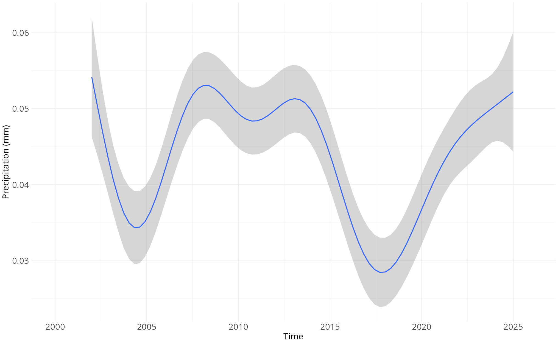
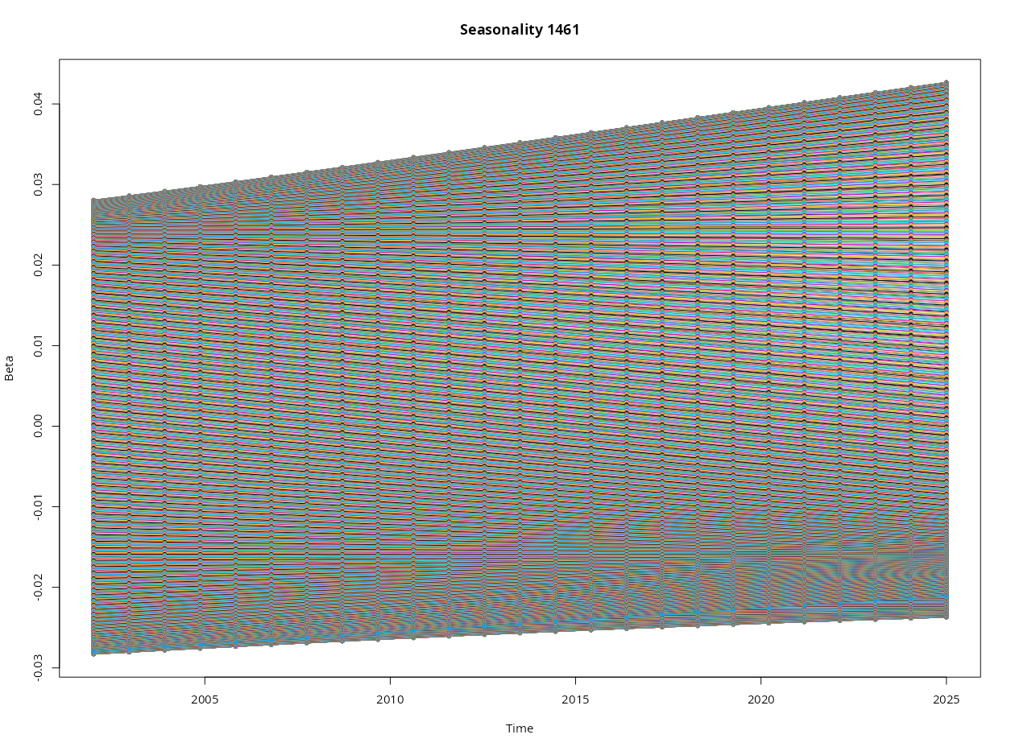
Figure P Trend in (a) baseline precipitation, and (b) seasonal precipitation range over time, for the study transect over time.

Current beetle assemblage and seasonal comparison
In the current samples (October 2022 and March 2023), a total of 42 beetle species were collected from the three families that were being studied, with a total of 1,633 individual beetles being present in the sample (1589 from October and 44 from March). Thirty-four of the species belonged to the Tenebrionidae, six species belonged to Carabidae, and two belonged to Cicindelidae. All 42 of the identified species were present in the October sample, however only five of these species were present in the March sample (Appendix S1). The highest mean abundance was observed in the Ericaceous Fynbos, with the Succulent Karoo site having the second highest mean abundance, and the Proteoid and Restioid Fynbos sites having similar mean abundances to each other. The lowest mean abundance was observed in the Strandveld and Alpine Fynbos sites. The mean species richness was similar across all of the different vegetation types, with the Proteoid Fynbos sites having the highest richness (Table F). For the March 2023 sample specifically, the highest richness and mean abundance were observed in the Succulent Karoo site (Figure C).
There were no general trends for species richness and abundance across altitude. However some notable observations were the presence of a very distinct abundance peak situated within the “1100m (W)” site (Table E). Also one specific site, “1300m (E)”, exhibits a very different assemblage structure and composition when compared to all other sites in the general slope trend across both sides of the transect. This site was very homogeneous and was dominated mostly by one single species (Cicindela lurida), which resulted in a site with relatively high abundance compared to its diversity (Figure D).
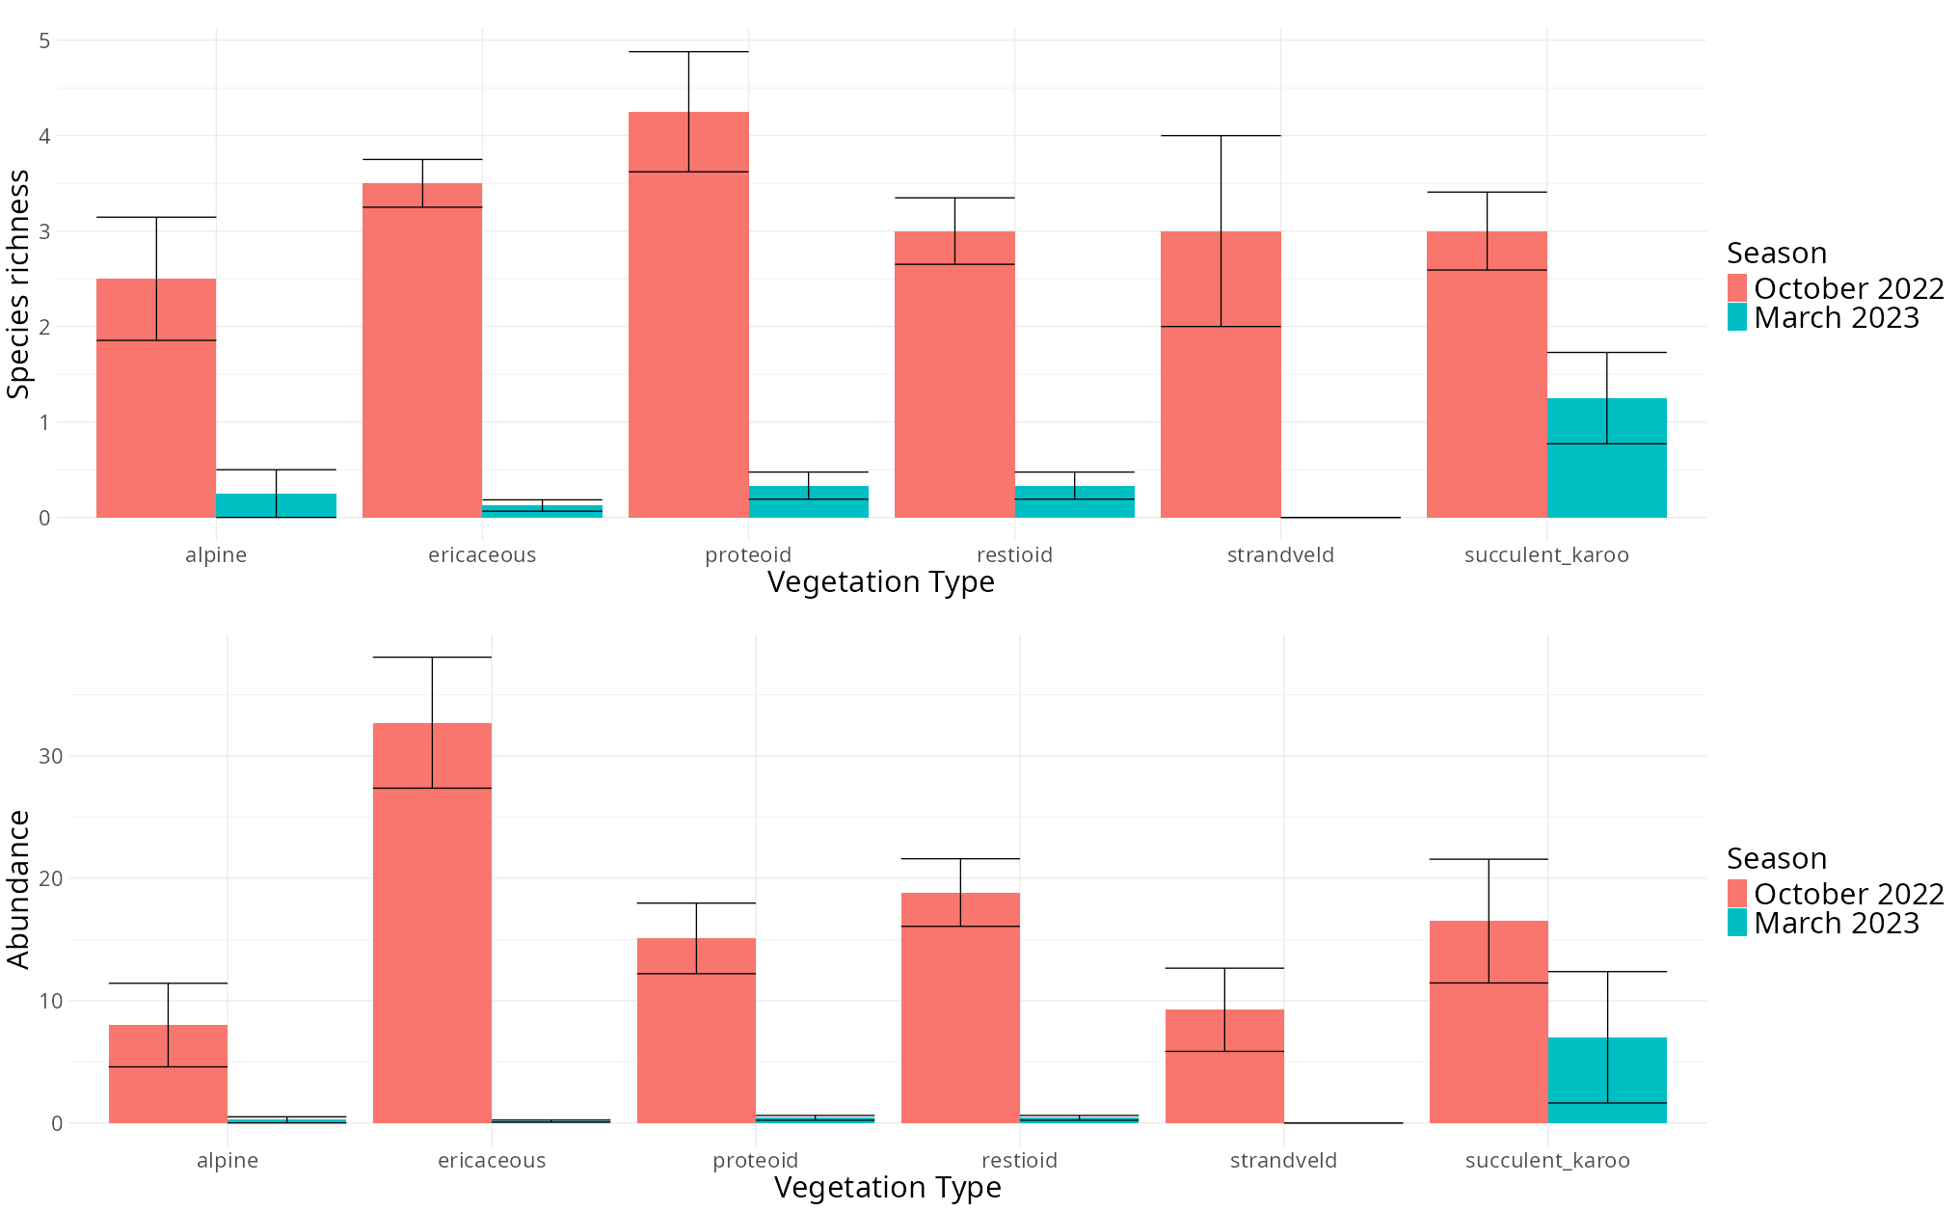
Figure C (a) Species richness, and (b) mean abundance across the different vegetation types present in the transect, separated by season.
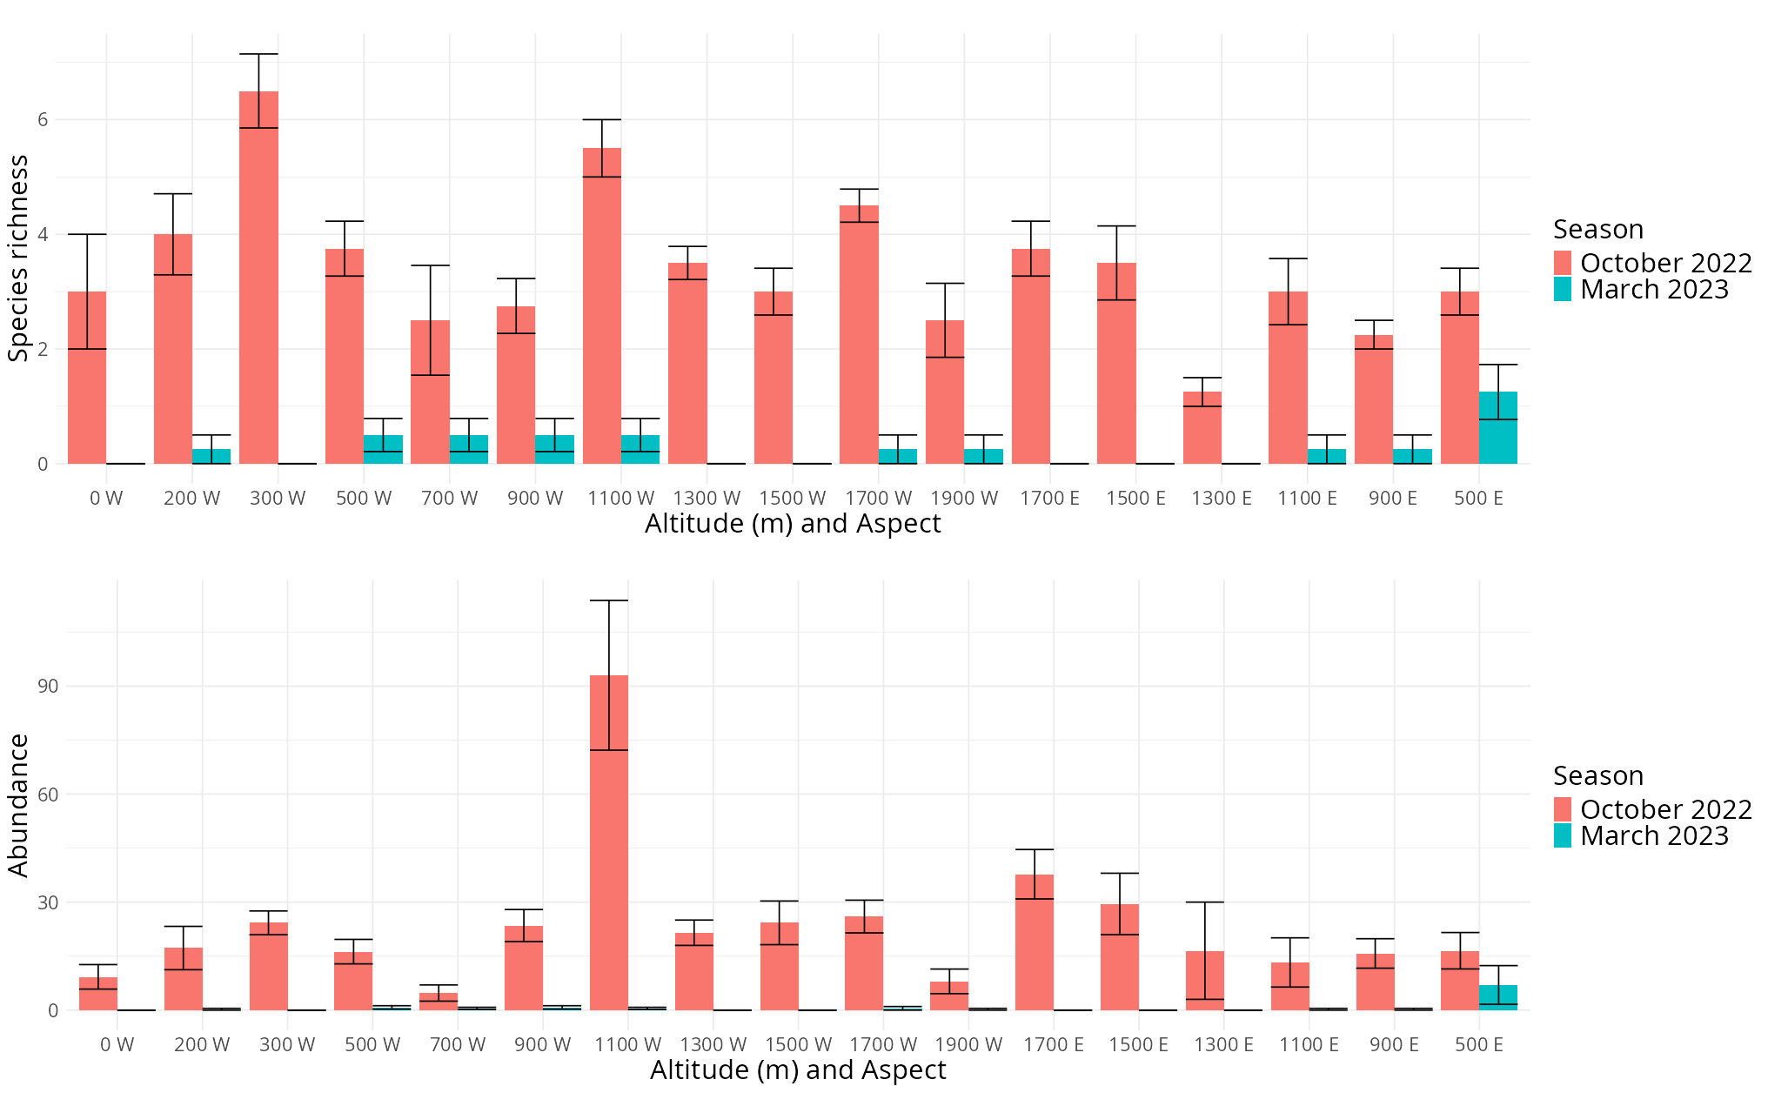
Figure D (a) Species richness, and (b) mean abundance across the altitudinal gradient of the transect, separated by season.

Some of the species shifted in their altitudinal range between seasons, with the range shifts differing between the two aspects of the transect. On the western slope four different species had an upwards contraction of their lower elevation limits, and two of these species also had a downwards contraction of their upper elevation limits (Figure Ea). On the eastern slope, three species experienced a downwards contraction of their upper elevation limits, while one species experienced an upwards contraction of its lower elevation limits (Figure Eb).
Comparing the abundance between the seasonal samples with an NMDS plot showed that aside from a few outliers, the two samples were still closely related to each other (Figure Fa). The comparison of species presence-absence showed that while the October 2022 sample still had many observations that were similar, the different observations for March 2023 didn’t show any signs of significant grouping (Figure Fb).
The NMDS plots comparing species abundance and presence between the different altitudinal sites showed that most of the altitudinal sites were similar to each other with only a few notable exceptions (Figure G). Site 11 (the summit, 1900m), site 14 (1300m (E)), and site 1 (Lambert’s bay, 0m (W)) were all distinctly different from the general grouping shown by the other sites.
Comparing the species abundance and presence between the different categories of vegetation groups in the sites showed that the different subgroups of Mountain Fynbos were all more similar to each other than the other vegetation types. The Proteoid and Restioid sites were the most similar with the Ericaceous sites only differing slightly. The Succulent Karoo site was also similar to the different Fynbos groups but much more closely clustered than the Fynbos sites. The Alpine and Strandveld sites were both very dissimilar to each other and the other groups previously mentioned. The Alpine site was especially very varied within the site itself (Figure H).

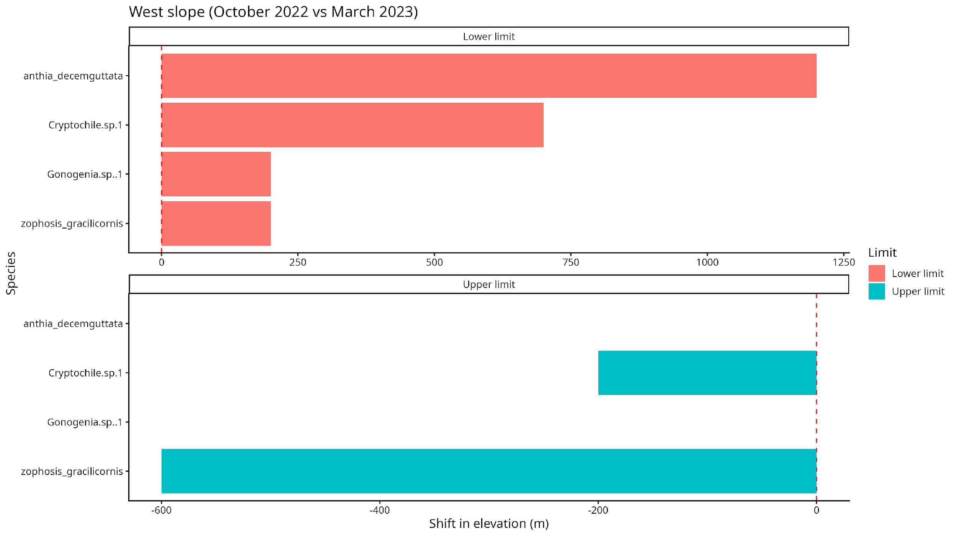
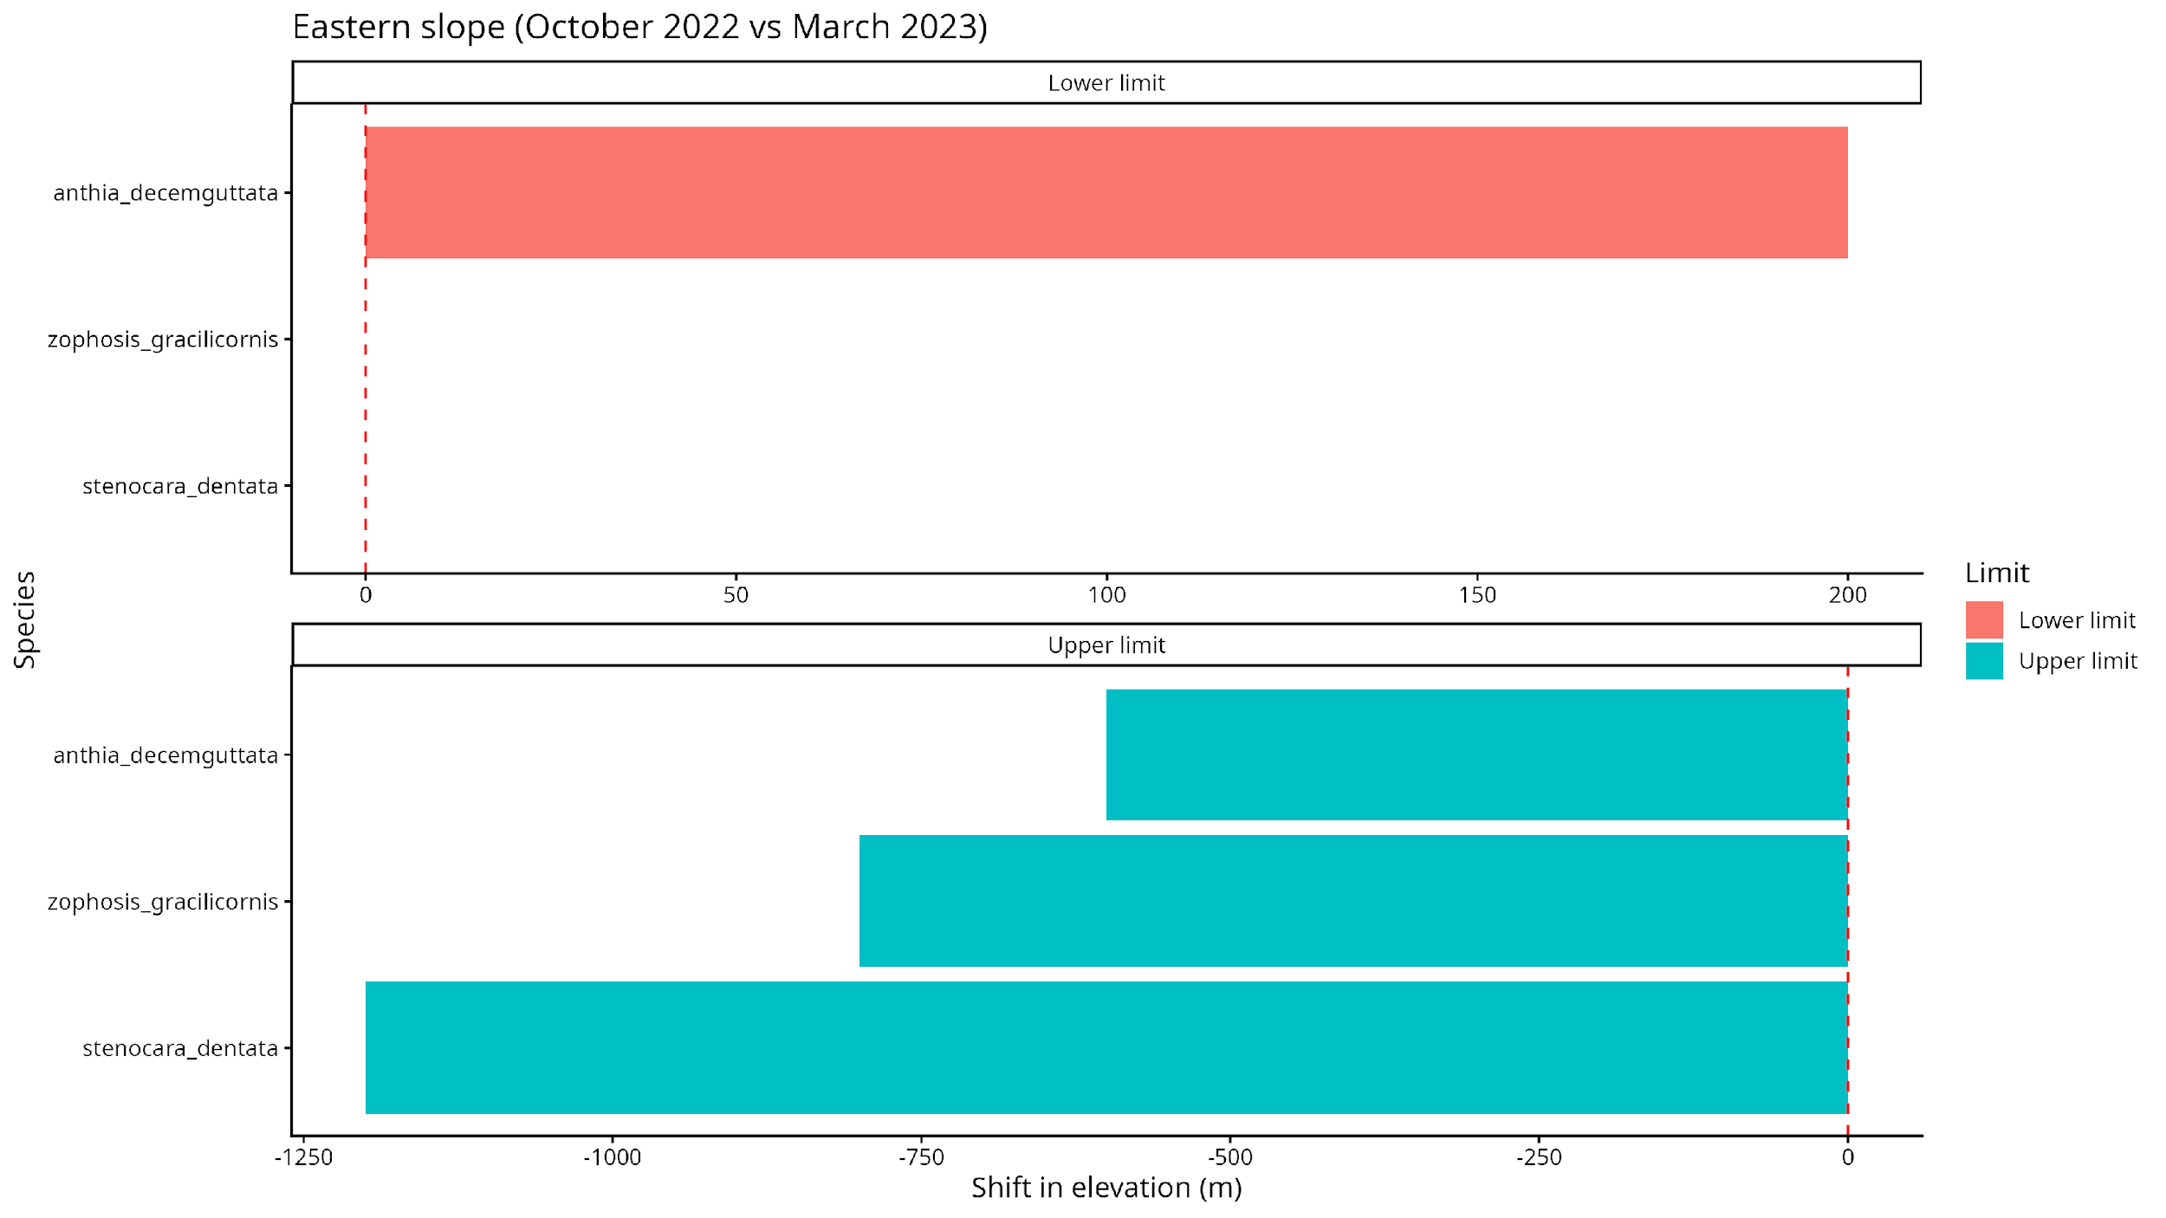
Figure E (a) Western slope, and (b) eastern slope altitudinal range limit shifts for relevant species between October 2022 and March 2023.

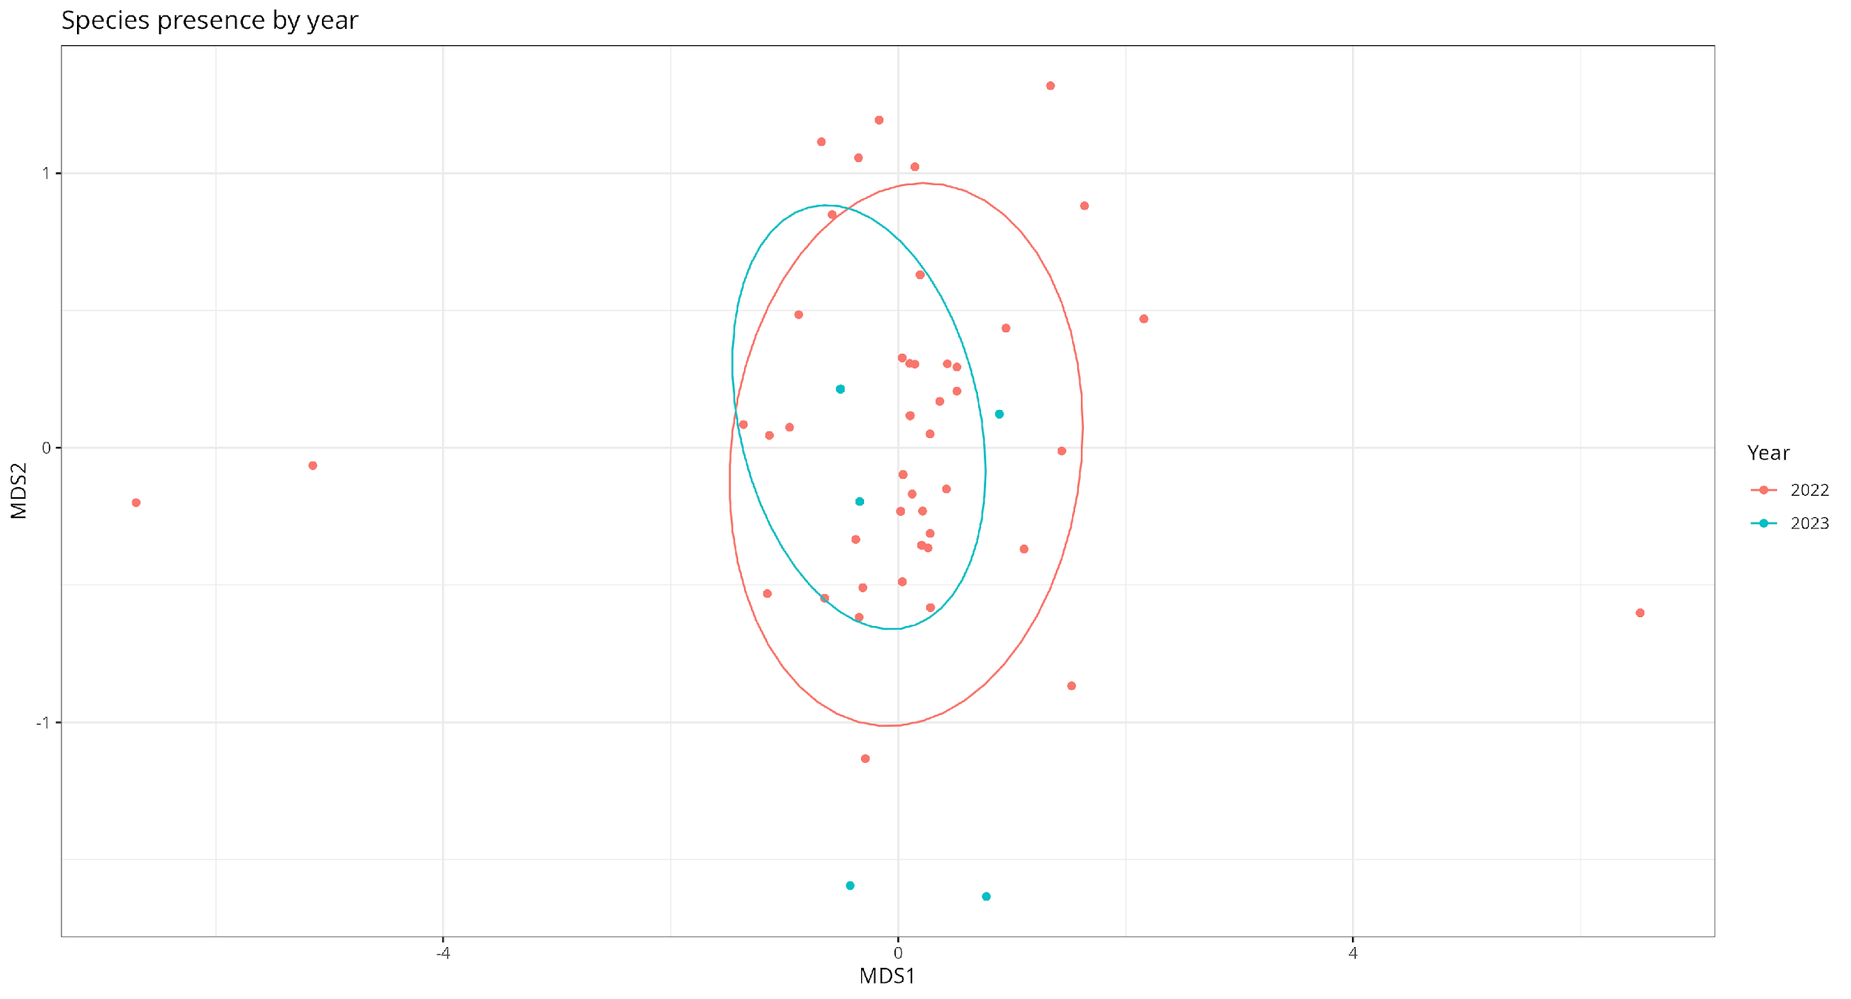
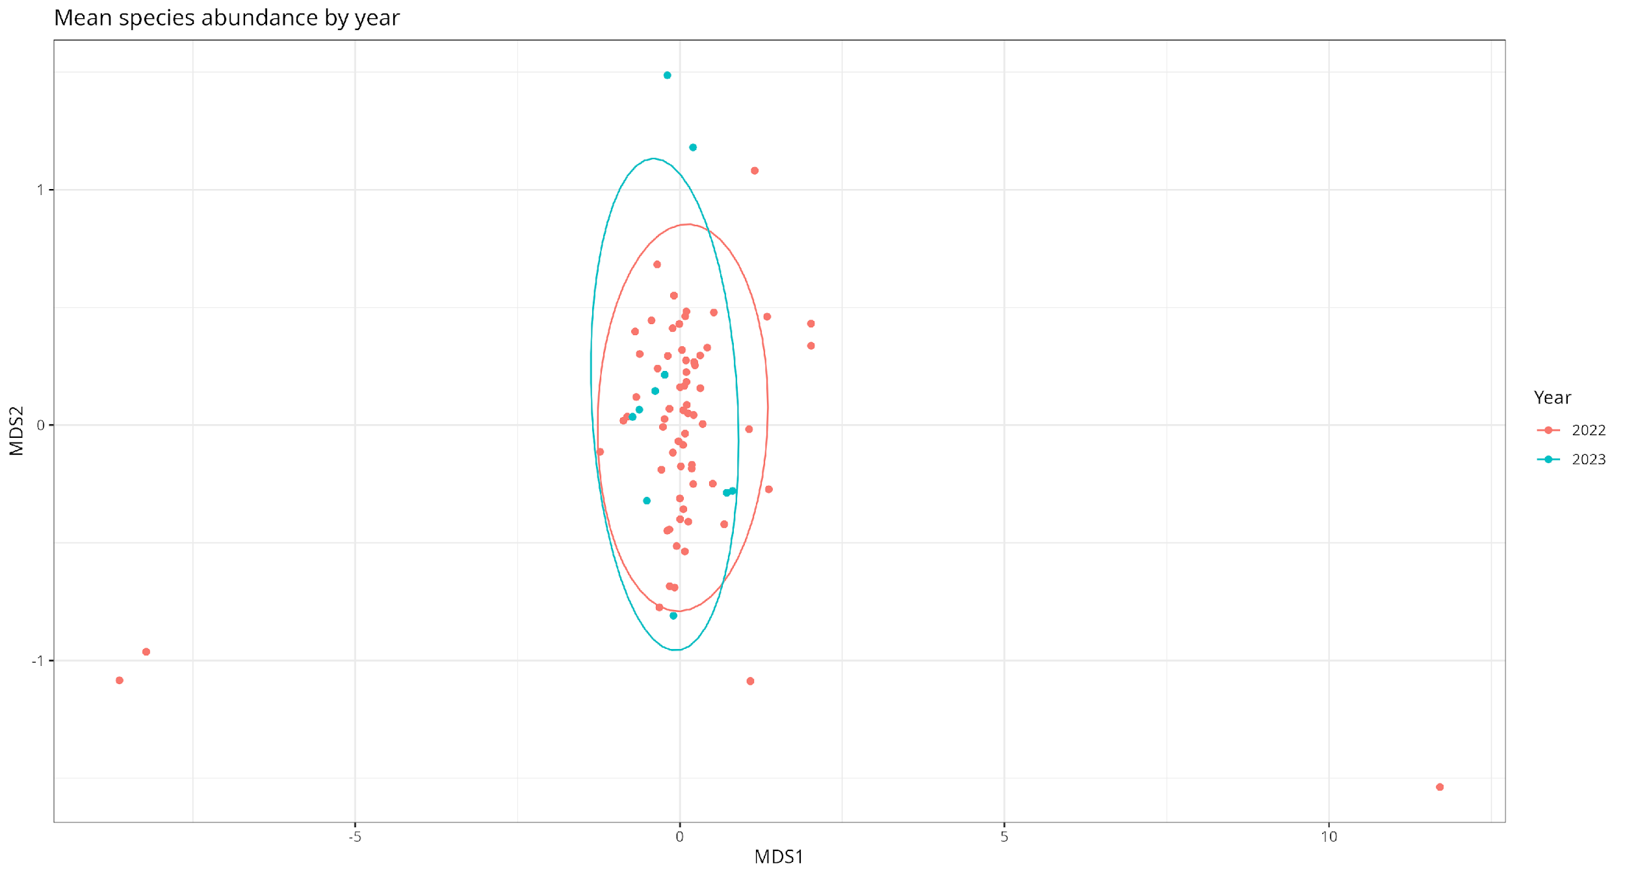
Figure F NMDS plot of (a) mean species abundance (stress = 0.1), and (b) species presence (stress = 0.09), compared between the two sampling seasons (October 2022 and March 2023).
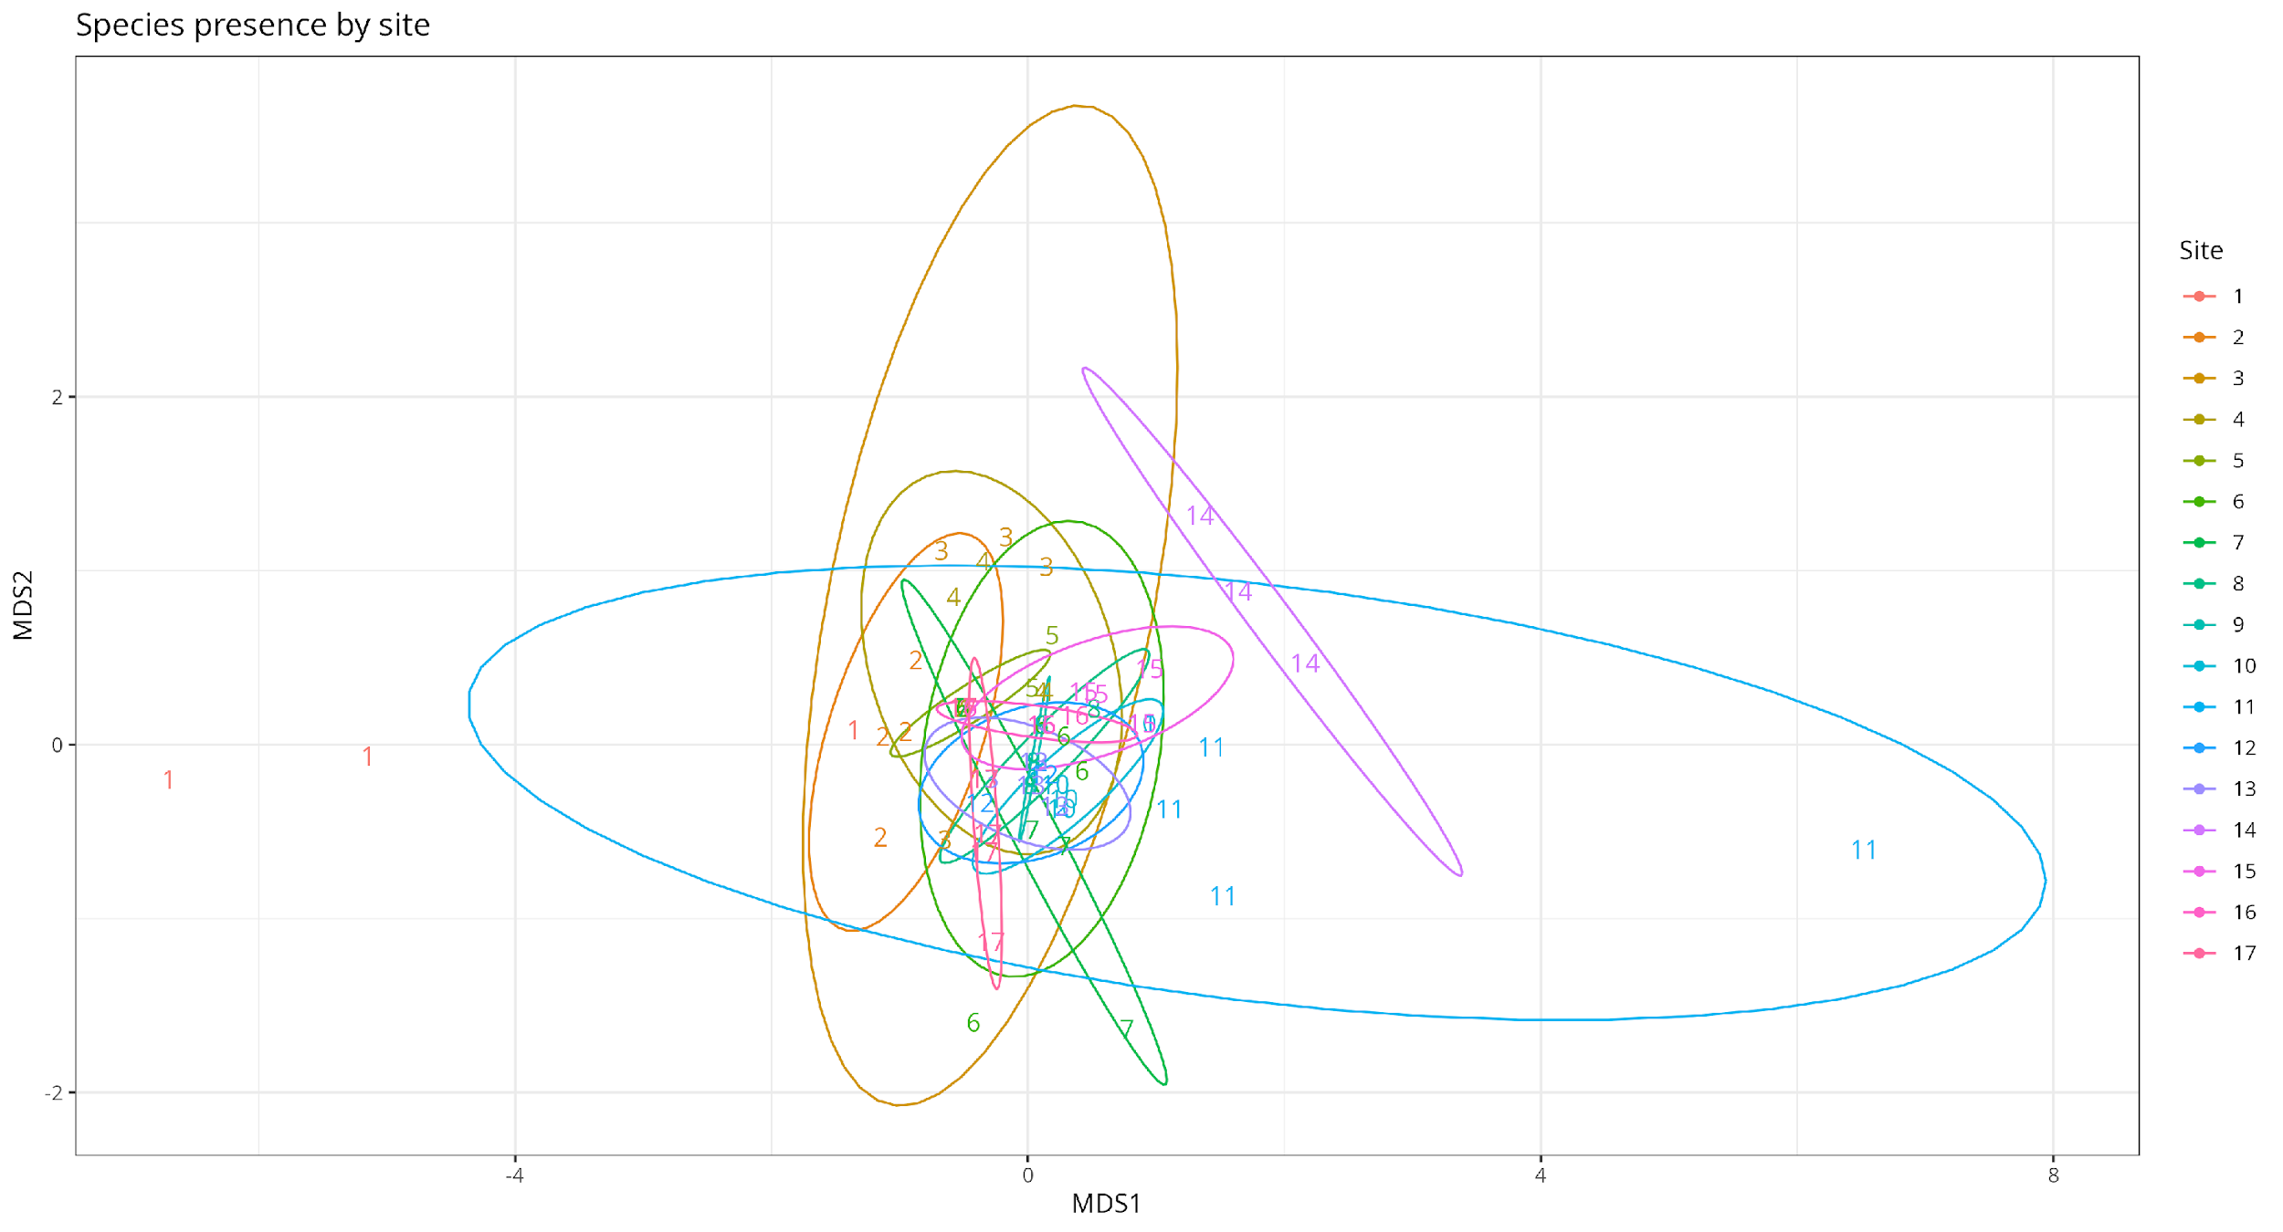
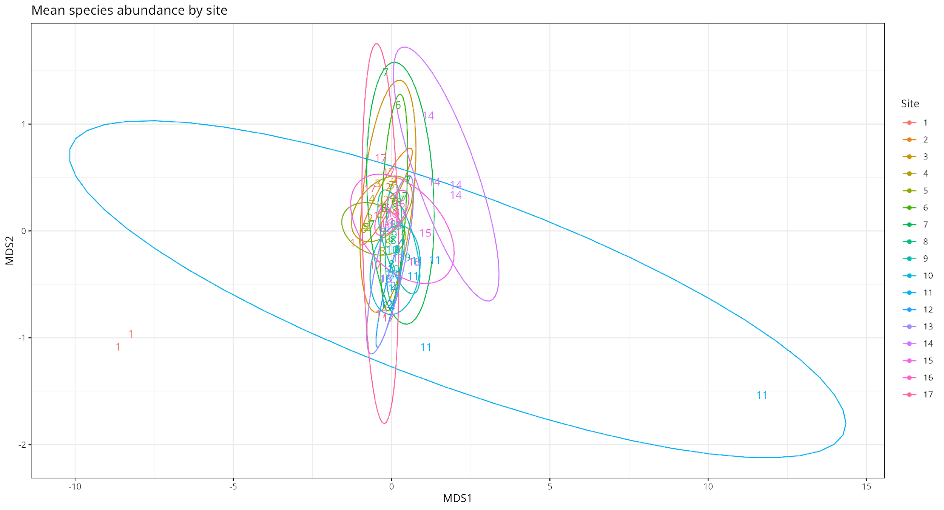
Figure G NMDS plot of (a) mean species abundance, and (b) species presence, compared between the different sites across the altitudinal gradient of the transect.
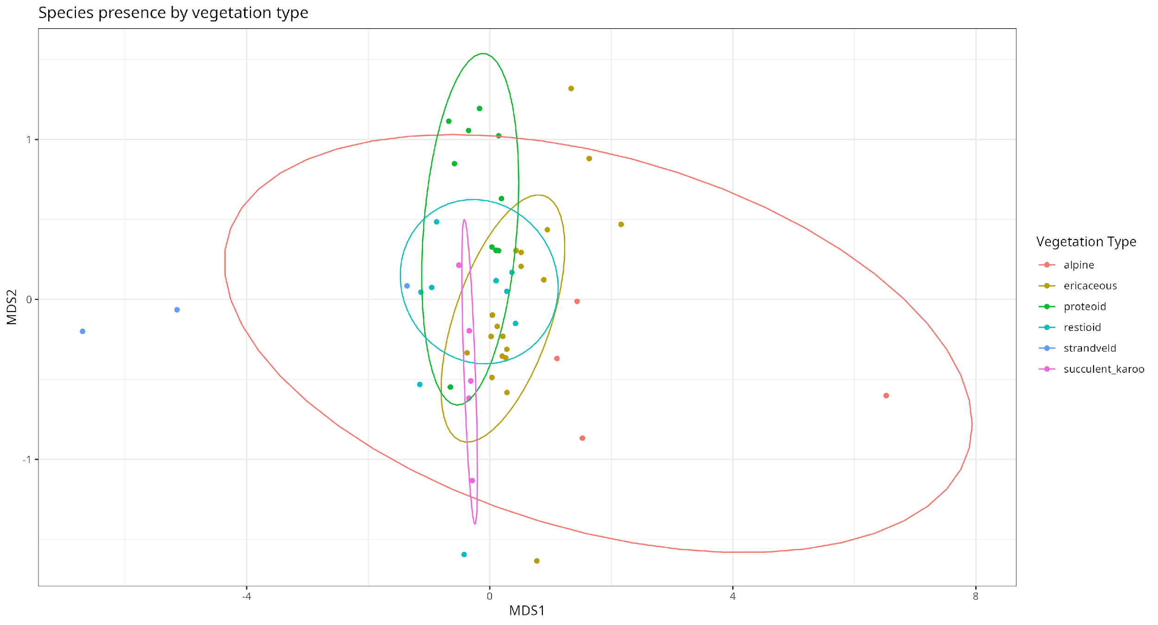
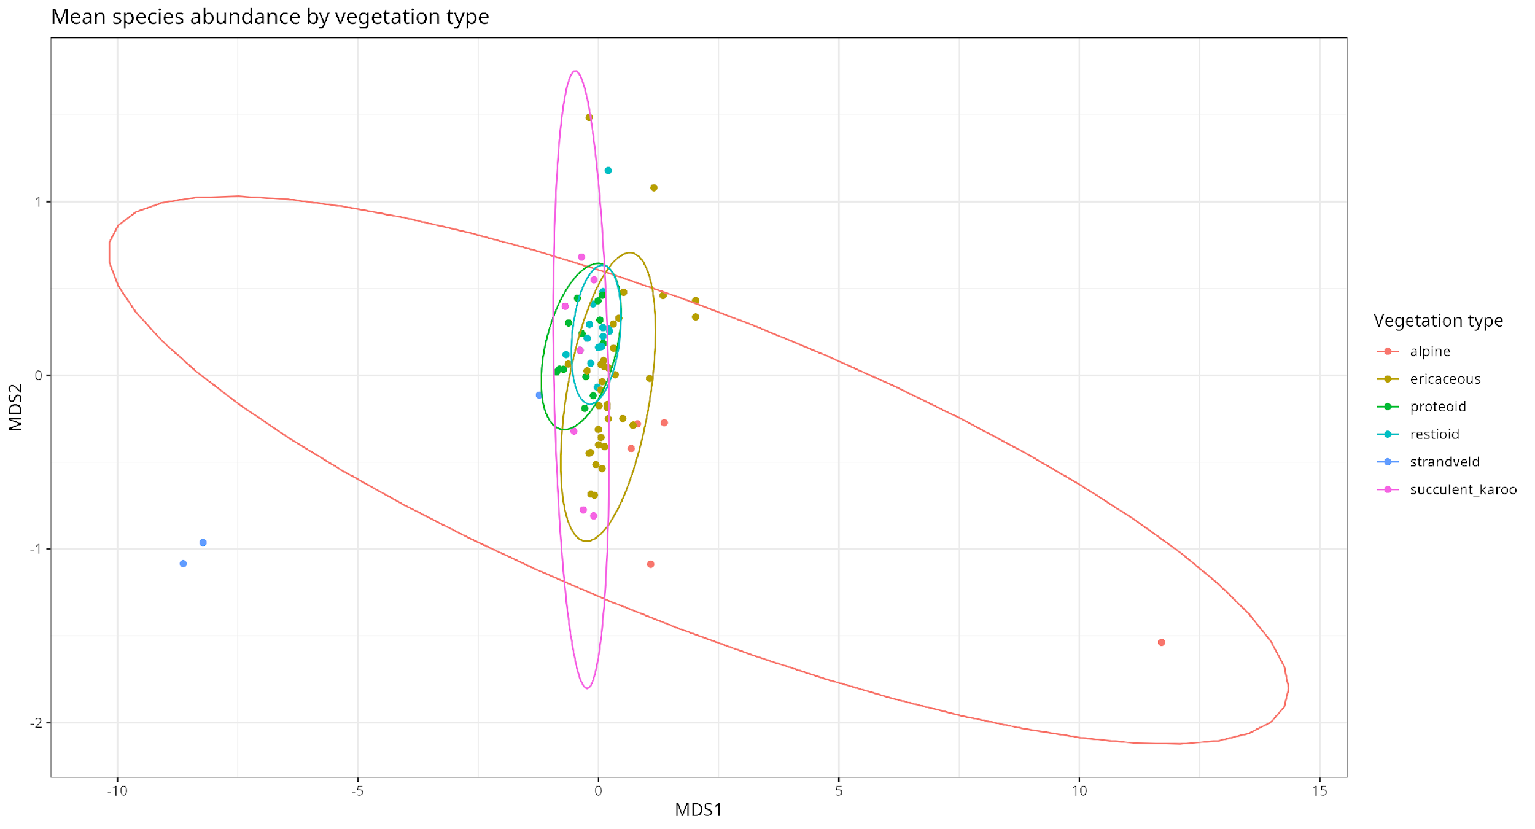
Figure H NMDS plot of (a) mean species abundance (stress = 0.1), and (b) species presence (stress = 0.09), compared between the two different vegetation types present across the sites of the transect.
Table F Mean species richness and abundance (± standard error) of beetles identified from October 2022 across the different vegetation types present within the transect.
Vegetation type | Abundance  (mean ± SE) | Species richness  (mean ± SE)
Alpine Fynbos | 8.25 ± 3.45 | 2.5 ± 0.645
Ericaceous Fynbos | 32.875 ± 5.36 | 3.5 ± 0.25
Proteoid Fynbos | 15.5 ± 2.85 | 4.25 ± 0.629
Restioid Fynbos | 19.25 ± 2.81 | 3 ± 0.348
Strandveld | 9.25 ± 3.4 | 3 ± 1
Succulent Karoo | 23.5 ± 8.86 | 3 ± 0.408

Sample-based species rarefaction curves showed that for the majority of the sampled sites, the sampled species did not reach the asymptote of the expected number of species present within those sites. Only two sites (900m (W), 1100m (E)) seemed to reach saturation for sampled species (Figure U).
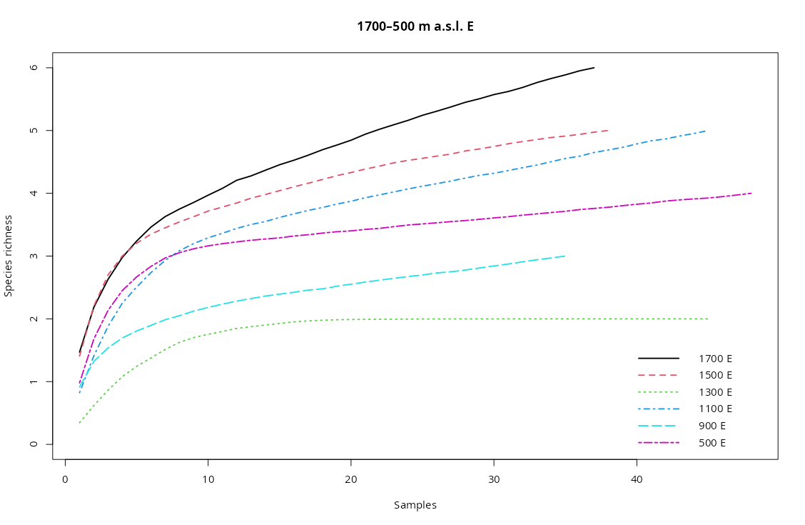
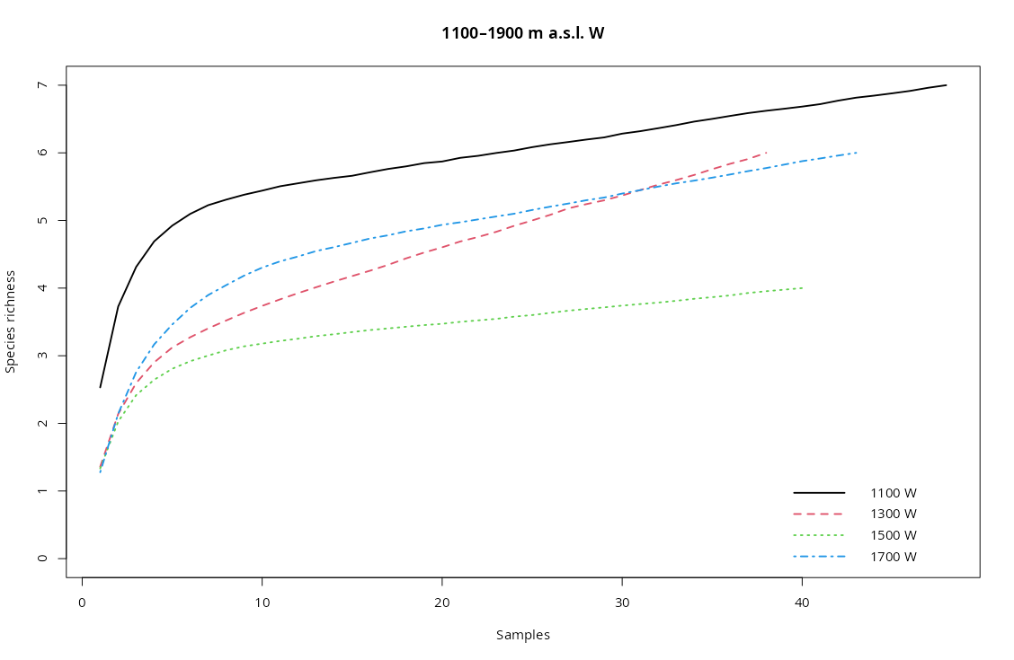
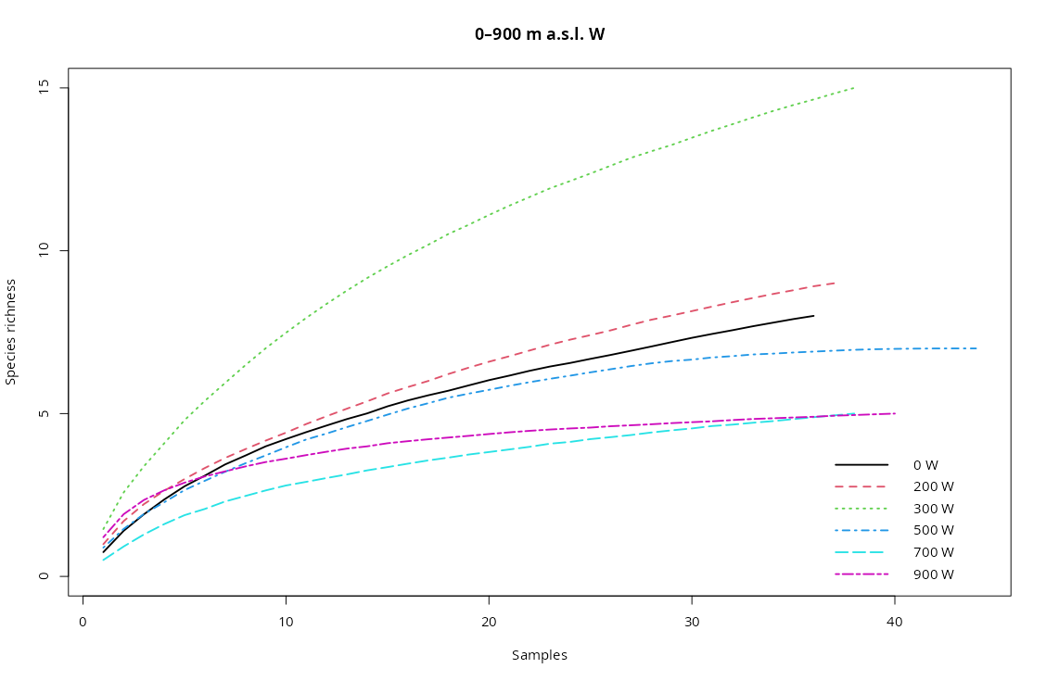
Figure U Sample-based species rarefaction curves of beetle assemblages at (a) sea level to 900m above sea level on the western slope, (b) 1100–1900m above sea level on the western slope, and (c) 1700–500m above sea level on the eastern slope.
Table E Mean species richness and abundance (± standard error) of all of the beetles identified from the October 2022 sample across the elevational gradient.
Elevation (m a.s.l.) | Abundance (mean ± SE) | Species richness (mean ± SE)
Western slope
0 | 9.25 ± 3.4 | 3 ± 1
200 | 17.5 ± 5.98 | 4 ± 0.707
300 | 24.25 ± 3.3 | 6.5 ± 0.645
500 | 17 ± 3.39 | 3.75 ± 0.479
700 | 5.25 ± 2.32 | 2.5 ± 0.957
900 | 24.25 ± 4.77 | 2.75 ± 0.479
1100 | 93.5 ± 20.6 | 5.5 ± 0.5
1300 | 21.5 ± 3.52 | 3.5 ± 0.289
1500 | 24.25 ± 6.06 | 3 ± 0.408
1700 | 26.5 ± 4.19 | 4.5 ± 0.289
1900 | 8.25 ± 3.45 | 2.5 ± 0.645
Eastern slope
1700 | 37.75 ± 6.86 | 3.75 ± 0.479
1500 | 29.5 ± 8.53 | 3.5 ± 0.645
1300 | 16.5 ± 13.5 | 1.25 ± 0.25
1100 | 13.5 ± 6.81 | 3 ± 0.577
900 | 16 ± 3.94 | 2.25 ± 0.25
500 | 23.5 ± 8.86 | 3 ± 0.408

Historical beetle population comparisons
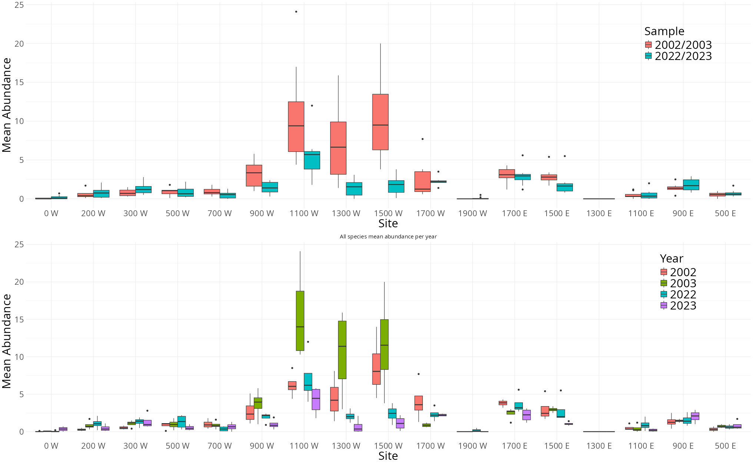
Figure I mean abundance of the three species separated by (a) the sampling period, and (b) the sampling year, across the sites of the altitudinal gradient.

Comparing the box plots of abundance and altitudinal site separated by year, it can be observed that in the historical samples the abundance seems generally greater, especially in 2003 (Figure I). Additionally, the peaks of abundance for the Anthia decemguttata and Zophosis gracilicornis within the respective years, have shifted from being at around 1300-1700m in altitude (on the western slope), to mostly converging at site 7 (1100m (W)) (Appendix S2).
The NMDS plots of mean abundance compared between the different sampling years shows that although there is some overlap between the observations from the years of the different sampling periods, there is a clear grouping of the historical samplings when compared to the contemporary ones (Figure J). This dissimilarity is not as present when comparing the presences of the species between the years, with a more uniform distribution present in the observations (Figure K). These plots therefore indicate that although the abundance of these three species has changed to some degree over time, the distribution of the populations over the transect has not changed as much. Individual sites have different specific relationships with both abundance and presence than when considering the transect as a whole (Appendix S3).
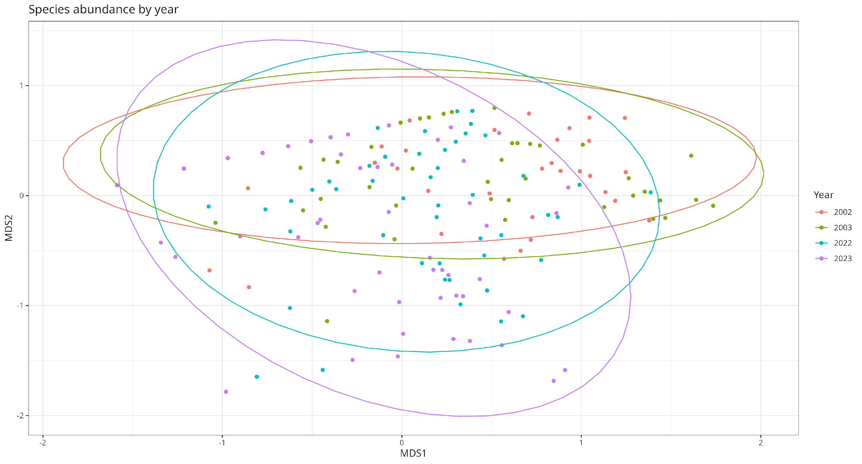
Figure J Abundance of the three key species separated by sampling year
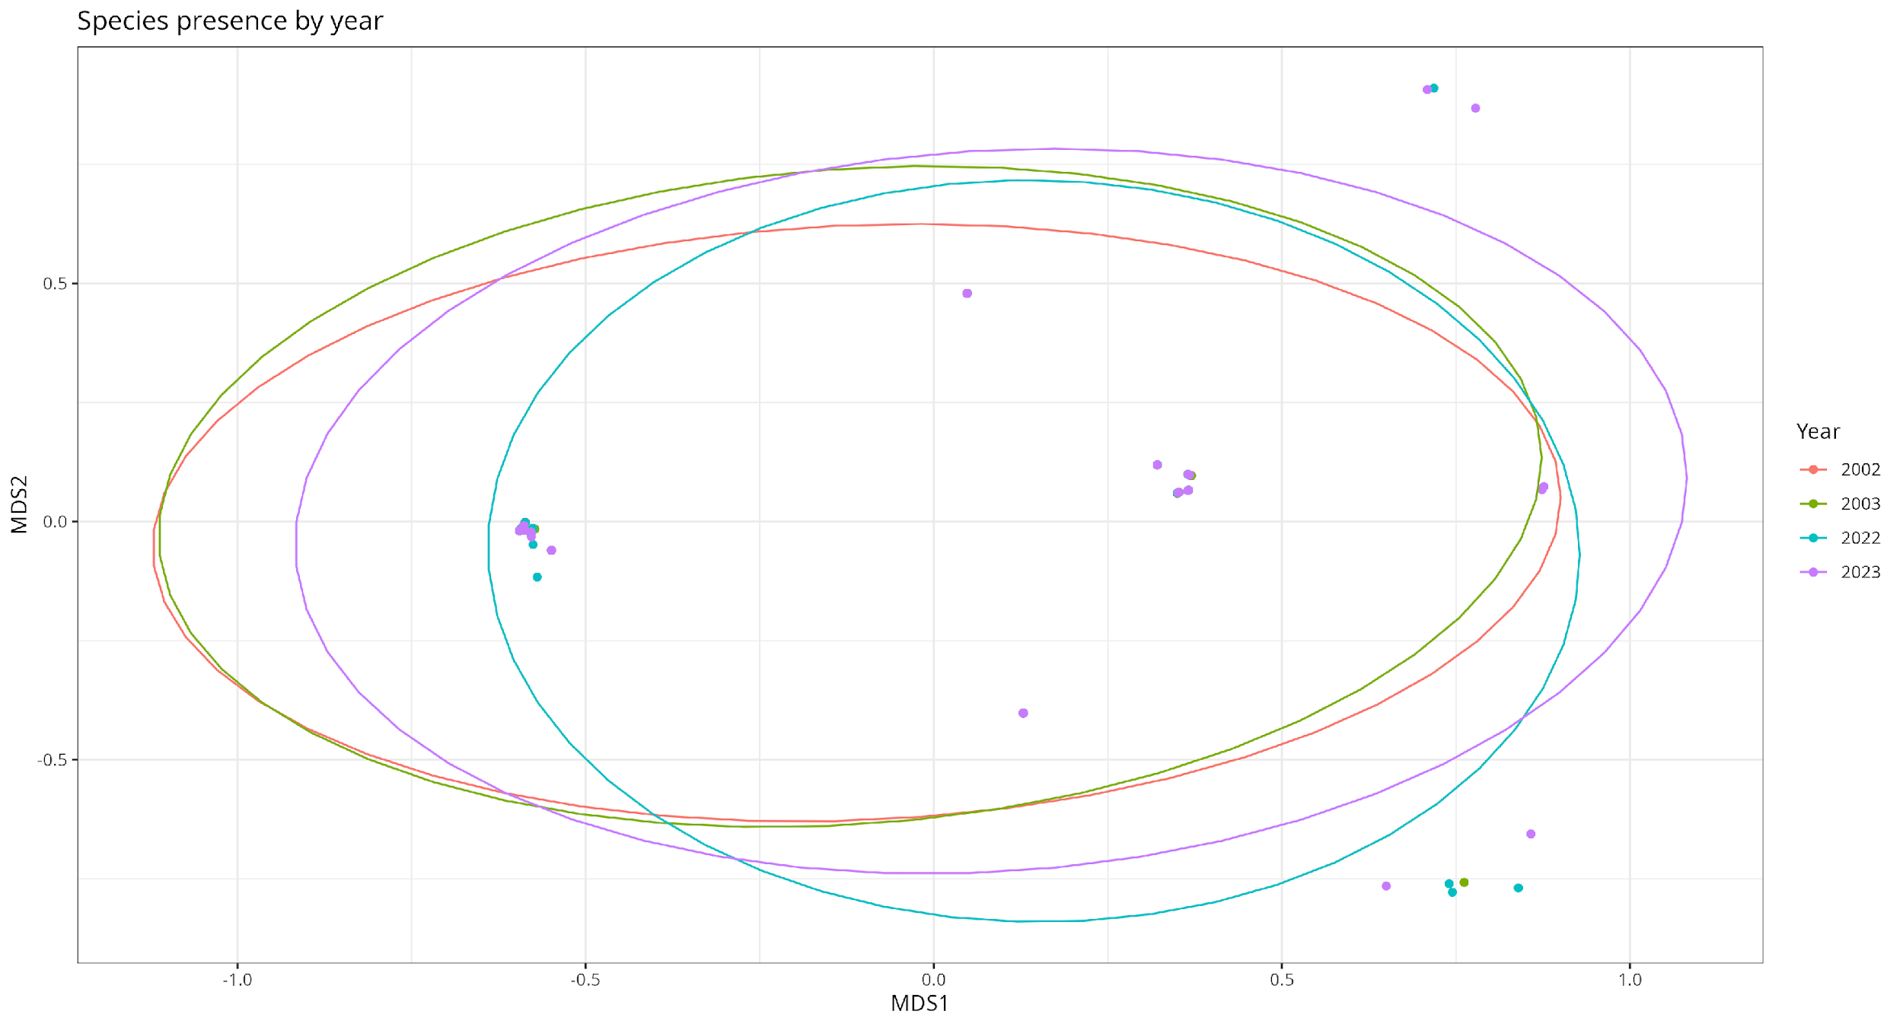
Figure K Presence of the three key species separated by sampling year

A heatmap of the Jaccardian similarities between the different altitudinal sites shows which of the sites are the most similar to each other (Figure L). It shows that different “blocks” of sites are similar to each other both due to matching vegetation types, as well as relative altitudinal placement across the gradient of the transect, even on opposing aspects. The two sites at the peak and at 1300m on the eastern aspect had no recorded observations of any of the key species in every year except for one, and due to multiple rows of zeroes, had to be excluded from the heatmap.
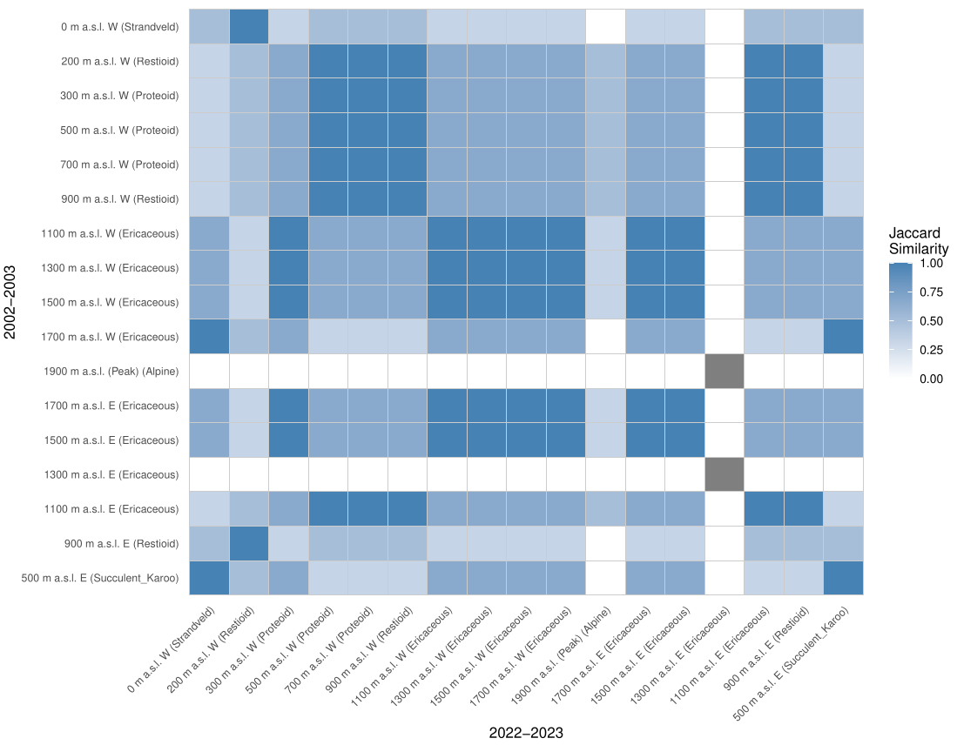
Figure L Heatmap of Jaccardian similarities between different altitudinal sites.

Dendrograms of the different sampling periods show how the different sites are related to each other with regards to beetle abundance (Figure M). From the clustering of the dendrogram branches it can be observed that in both sampling periods, for the most part the sites are separated into two main groups. The first group consists of the Proteoid and Restioid vegetation sites, and the second group consists of the mid-high altitude Ericaceous sites. The site at 1300m on the eastern slope is different from every single other site, along with the peak of the transect.
The GLMMs were used to quantify the difference in abundance between the years and sampling periods. When all of the species and sites are considered together, there is a significant 47% decline in abundance (z = -22.80, P < 0.001, Appendix TA) between the 2002-2003 and 2022-2023 samples. When considering each of the years individually, there was also a significant difference in abundance between the sites within the sampling periods (Table D). There was a 43% increase in abundance between October 2002 and 2003 for all species (z = 10.697, P < 0.001, Appendix TB). The majority of this increase in October 2003 was due to Zophosis gracilicornis, experiencing a 54% increase in abundance within that 1 year gap (z = 11.194, P < 0.001, Appendix TZ). When analysing each individual species by themselves, there were varying observed responses over time. Anthia decemguttata did not show significant changes in abundance between sampling periods. Stenocara dentata showed a significant 27% increase (z = 3.713, P < 0.001, Appendix TS) in abundance over time. Zophosis showed a significant 66% decrease (z = -28.82, P < 0.001, Appendix TZ) in abundance.
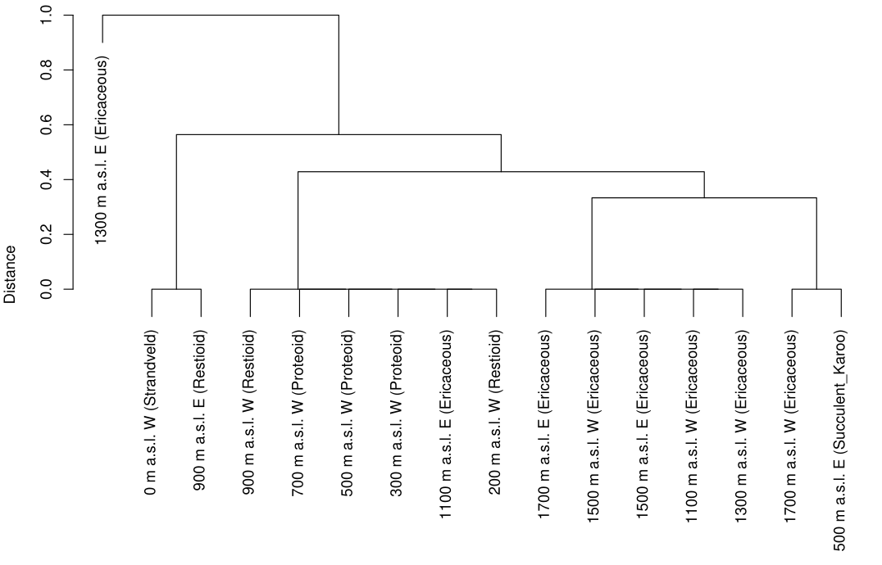
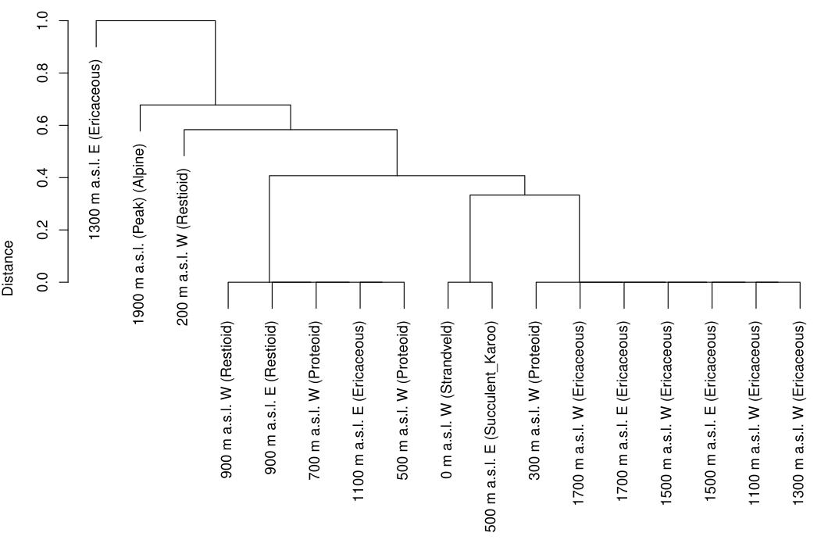
Figure M Dendrogram showing the hierarchical clustering of the different sites across the transect in both (a) the 2002-2003 sampling period, and (b) the 2022-2023 sampling period.

The comparisons between species density between the two sampling periods showed that there were minimal differences in density between the three types of Mountain Fynbos and Succulent Karoo, but there changes in species density observed for the Alpine Fynbos and the Strandveld (Table H).

Table H Mean species density (± standard error) compared between the beetle assemblage sampled between the different sampling periods, grouped by vegetation type.
Vegetation type | 2002/2003  (mean ± SE) | 2022-2023  (mean ± SE)
Strandveld | 7 ± 0.567 | 3 ± 1
Restioid Fynbos | 3.67 ± 0.491 | 3 ± 0.348
Proteoid Fynbos | 4.83 ± 0.527 | 4.25 ± 0.629
Ericaceous Fynbos | 3.28 ± 0.197 | 3.5 ± 0.25
Alpine Fynbos | 1.12 ± 0.227 | 2.5 ± 0.645
Succulent Karoo | 2.88 ± 0.227 | 3 ± 0.408

Exploratory models
For the historical assemblage comparisons, the first two canonical axes together explained 52% of the variance observed when comparing the sample and environment (Axis 1: F = 229.95, P < 0.001; Axis 2: F = 169.55, P < 0.001). A total of twelve explanatory factors were selected to significantly explain the beetle abundance variance (R² = 0.63) (Table G). Of these variables ten were environmental factors and two were the altitudinal site and the sampling period. The first axis is represented by the environmental gradients of an increase in the mean monthly maximum precipitation, the percentage proportion of calcium in the mineral composition of the soil, wind direction, and a decrease in the vegetation cover and the free calcium ions in the soil. The second axis is represented by an increase in the mean monthly maximum air temperature, the range of the monthly air temperature, mean monthly maximum ground temperature, the percentage proportion of magnesium in the soil, surface incident shortwave radiation, and a decrease in the pH of the soil and the relative humidity (Figure RDA1).
GLMMs showed that Zophosis gracilicornis abundance was affected positively by an increase in the air temperature range, an increase in the relative atmospheric humidity, an increase in the percentage of rock as part of soil composition, and an increase in mean maximum monthly precipitation, and a changing wind directions. Their abundance had a negative relationship with mean monthly maximum ground temperatures, and mean monthly maximum air temperatures (Appendix RZ). Stenocara dentata abundance had a positive relationship with percentage magnesium composition in soil, calcium content in soil, changing wind directions, an increase in the percentage of rock as part of soil composition, an increase in the ground vegetation cover, an increase in solar radiation, and an increase in the mean monthly maximum precipitation. The Stenocara dentata had no significant negative relationships with any of the measured environmental variables (Appendix RS). The Anthia decemguttata did not change significantly in abundance over time, however their distribution was still altered over time. The environmental variables that affected their distribution over time were percentage magnesium composition in soil, increase in the air temperature range, an increase in the ground vegetation cover, and an increase in the mean monthly maximum precipitation. These variables all had a positive relationship with their distribution across the transect. Conversely, percentage magnesium composition in soil, mean monthly maximum air temperature, and changing wind direction all had a negative effect on their distribution (Appendix RT).
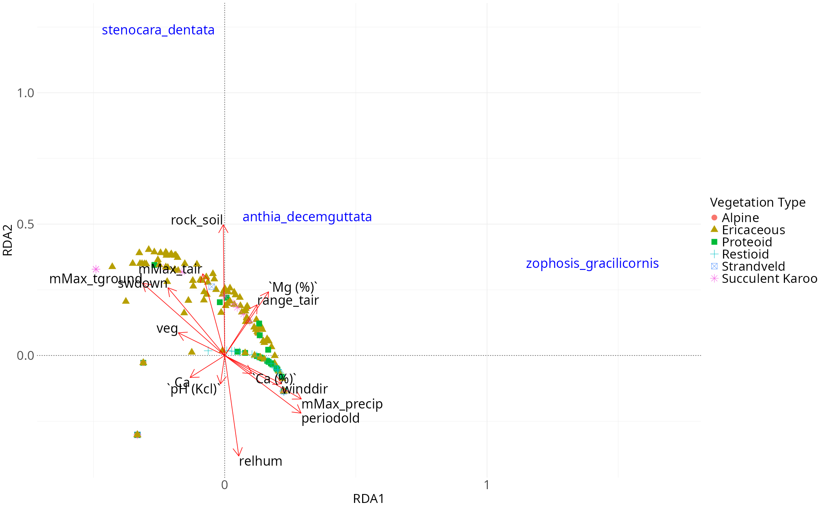
Figure RDA1 Biplot showing the factors that most significantly explained the variance in the beetle abundance across the historical sampling comparisons, with the relevant vegetation type indicated. (mMax_tair: mean monthly maximum air temperature, mMax_tground: mean monthly maximum ground temperature, swdown: incident shortwave radiation, Mg (%): percentage proportion of magnesium in soil composition, veg: ground vegetation cover, Ca: free calcium ions in soil, Ca (%): percentage proportion of calcium in soil composition, pH (Kcl): pH of the soil, mMax_precip: mean monthly maximum precipitation, relhum: relative humidity)

When considering the 2022 sample alone, the first two canonical axes together explained 37% of the variance observed when comparing the sample and environment (Axis 1: F = 31.0864, P < 0.001; Axis 2: F = 30.2172, P < 0.001). A total of eight explanatory factors were selected to significantly explain the variance in beetle abundance across all of the identified species (R² = 0.59). The first axis is represented mostly by an increase in the percentage proportion of magnesium in the soil, and is represented to a much lesser extent by the ground vegetation cover. The second axis is represented by an increase in the percentage proportion of sodium in the mineral composition of the soil, the pH of the soil, and a decrease in the mean monthly air temperature, monthly range of the ground temperature, and the mean monthly precipitation (Figure RDA2).
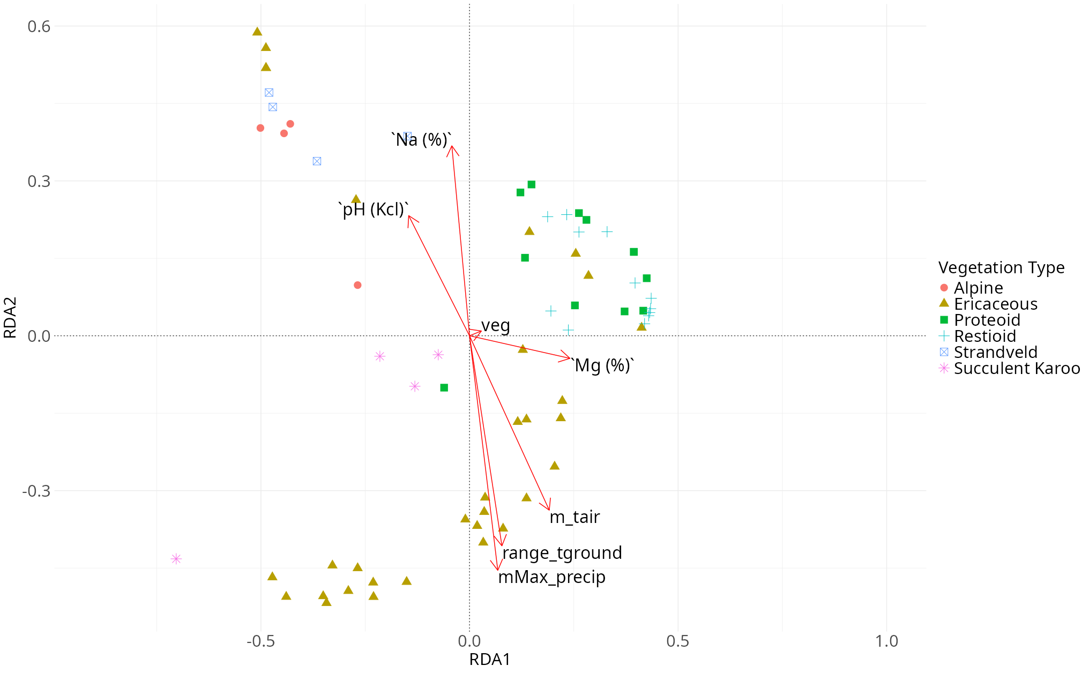
Figure RDA2 Biplot showing the factors that most significantly explained the variance in the beetle abundance for all species identified in the October 2022 sample. (Na (%): percentage proportion of sodium in soil composition, pH (Kcl): pH of the soil, veg: ground vegetation cover Mg (%): percentage proportion of magnesium in soil composition, m_tair: mean monthly air temperature, range_tground: monthly range of ground temperature, mMax_precip: mean monthly maximum precipitation)

Table D Mean abundance (± standard error) of Anthia decemguttata, Stenocara dentata, and Zophosis gracilicornis, at each elevation in October across the four years of the historical comparisons.
(b)
(a)
Elevation (m a.s.l.) | 2002  (mean ± SE) | 2003  (mean ± SE) | 2022  (mean ± SE) | 2023  (mean ± SE)
Western slope
0 | 0.25 ± 0.25 | 0.5 ± 0.289 | 0.5 ± 0.5 | 3.5 ± 1.55
200 | 2.75 ± 0.854 | 8.5 ± 2.99 | 11 ± 3.89 | 4.75 ± 2.25
300 | 5.25 ± 1.11 | 10.5 ± 2.33 | 13 ± 2.94 | 13.5 ± 4.91
500 | 8.25 ± 2.43 | 9.75 ± 3.33 | 13 ± 4.71 | 5.25 ± 1.8
700 | 10 ± 3.03 | 8.75 ± 2.69 | 3.75 ± 1.6 | 6.5 ± 2.72
900 | 27.25 ± 8.74 | 36.75 ± 9.94 | 19 ± 3.39 | 9.75 ± 3.35
1100 | 62.5 ± 8.45 | 156 ± 32.1 | 71 ± 17.2 | 41.25 ± 9.6
1300 | 44.75 ± 14.4 | 104.25 ± 29.6 | 20.75 ± 3.92 | 7 ± 4.85
1500 | 86.5 ± 20.3 | 117.25 ± 33.8 | 24 ± 6.1 | 11.25 ± 4.75
1700 | 40.5 ± 13.3 | 8.75 ± 1.38 | 23.25 ± 4.35 | 22.25 ± 0.75
1900 | 0 ± 0 | 0 ± 0 | 1.75 ± 1.18 | 0 ± 0
Eastern slope
1700 | 38 ± 2.35 | 24 ± 4.06 | 36.75 ± 6.54 | 22 ± 4.49
1500 | 30 ± 8.26 | 29.5 ± 1.85 | 28.5 ± 8.85 | 10.5 ± 1.26
1300 | 0 ± 0 | 0 ± 0 | 0 ± 0 | 0 ± 0
1100 | 5.25 ± 1.93 | 4.25 ± 2.66 | 9.25 ± 3.97 | 2 ± 0.913
900 | 13.5 ± 4.33 | 14.5 ± 1.04 | 15.5 ± 3.86 | 20.25 ± 4.09
500 | 3.25 ± 1.49 | 7.25 ± 1.11 | 6.25 ± 1.49 | 8.25 ± 2.98

Discussion
The approximately 97% decrease in sampled abundance between the October 2022 season and the March 2023 season is comparable to past studies that have also observed similar levels of seasonal beetle population fluctuation (Ndozi, Gohole and Mapaure, 2025). In other southern hemisphere studies the patterns of beetle abundance and prevalence followed a general trend with the difference in the seasonal samples observed in the Cederberg transect. Beetle abundances tend to have multiple seasonal peaks throughout the year with the one occurring in the warmer months, in late spring around September/October, being either the maximal peak or one of a few (Pinheiro et al., 2002; Wardhaugh, Stone and Stork, 2018). However when regarding all of these prior examples, the warm season is also the season with increased rainfall in the respective environments. Therefore there was a lot of evidence revealed through analysis that much of the variation in increasing beetle abundance could be attributed to increasing rain in the warmer months along with the respective temperature changes (Wang et al., 2014).
Other possible reasons behind the large decrease in observed abundance and species richness between seasons could be due to many different species exhibiting reduced physical activity during the colder seasons. In other Mediterranean climate studies, there have been examples of Tenebrionidae that have periods of diapause as adults, such as the Pimelia bipunctata (Fattorini, 2023). Carabidae have also been shown to commonly undergo periods of seasonal diapause as adults (Hodek, 2012). These observations can potentially explain the seasonal assemblage changes observed across this study as occurring due to sampling limitations rather than actual changes in the baseline assemblage for living beetles. Due to pitfall traps requiring surface activity of the arthropods that will be trapped in the trap, the observed results of pitfall traps will only adequately represent species that are active in the season within which sampling is being carried out (Byeon et al., 2022). Determining whether the seasonal presence or absence of certain species is due to sampling biases or because of generational turnover will require research into the phenology of the relevant species and whether or not they experience adult diapause or not.
In other studies involving environments with wet summers, rainfall is being seen as less of a determining factor in beetle assemblage size and structure than previously thought (Grimbacher and Stork, 2009). Other studies that were observing environments with dry summers and wet winters, as well as the historical study for this transect, did not report any significant effects of precipitation on the beetle assemblages (Botes, McGeoch and Chown, 2007; Ramírez-Hernández, Micó and Galante, 2014). A potential reason for this might be that since these environments are generally arid compared to other comparable studies, the species present are less mutable to assemblage changes due to precipitation. Despite the past research in similar environments not showing a generally significant relationship between local beetle assemblages and precipitation, in this study all three of the key species used in the historical comparison had a positive relationship with increasing levels of maximum precipitation. This could be potentially due to the beetle assemblages in this study, and especially the detritivorous species, being more affected by the availability and distribution of their preferred vegetative habitats.
Vegetation diversity and biomass have been shown to be the primary driver of diversity and community structure in certain insect groups (Gaona et al., 2025). Additionally, changes in distribution of vegetation can affect insects at various levels of ecological specificity. Specialist species such as Papilio cresphontes have been observed to have their species distribution ranges expand rapidly as their host-plant has undergone a range expansion (Wilson et al., 2021). The generalist leaf beetle Cerotoma trifurcata have been modelled to have their ranges be heavily restricted by the soybean plants that they consume as their preferred host-plants (Berzitis et al., 2014). The prevalence of the soybean plants that they mostly feed on has meant that the mass availability of food allows the species to have the large range that it currently inhabits.
These prior points are relevant as the ecology of the most abundant beetle in this transect (Zophosis gracilicornis) is relatively unknown, however whether they are generalists or specialists, environmental vegetation changes might explain why they have undergone an intense loss of abundance and altitudinal range shift. Increasing temperatures have also generally indicated an increase in vegetation and an expansion of vegetation into higher altitudes as temperature conditions make it suitable for them (Zu et al., 2021). As seen in this study, vegetation cover has been increasing in general across all altitudinal bands, meaning that plant species from different elevations could be shifting in range into altitudes in which they were previously not present. These vegetative altitudinal range shifts come with an associated increase in competition and a restructuring of the vegetative communities in the relevant environments. Meaning that even with increased vegetation cover and range for vegetation in general, the specific host-plants for certain species might be under competitive pressure (Harvey and Malcicka, 2015). As the Zophosis gracilicornis is found mostly in Ericaceous Fynbos sites (Appendix ADDNB), a particular type of vegetation found within those sites could be a major determining factor as to their distribution and ideal habitat.
One particular site (1300m (E)), exhibited a beetle assemblage that did not match the trends observed in the sites with the same vegetation type as it on the Eastern aspect of the mountain, or the trends in diversity and observed species in general. This site was mostly dominated by one single species—Cicindela lurida—and a couple of small abundances of herbivorous beetles. Cicindela lurida was also found notably found in high abundances in one other notable site, being the summit site of 1900m. This dominance of a single predatory species is not a recent phenomenon. The October 2002-2003 sample also had this same trend. The reason behind this site in particular having a unique composition of beetles that breaks the general pattern was one that was definitively concluded within this study. A possible reason could include vegetation differences that were not recorded in this study. Another possible reason that could explain the lack of predatory Carabidae specifically are the aforementioned observations that they as a family specifically seem to be affected by interspecific competition by other predators and availability of prey, especially if they are both preying on the same groups (Niemelä, 1993; Lövei and Sunderland, 1996; Gonçalves et al., 2021).
There was a consistent 0.19°C increase in air temperatures across the entire transect, as a trend over time when accounting for all seasonal fluctuations. However, the changes observed at microclimate level temperatures were not similarly consistent between the different altitudinal sites. Some of the sites exhibited ground temperature changes that fluctuated in line with the air temperature changes that were also calculated over time. However in certain sites (such as the 700m (W) example), there was a steady increase of soil microclimate temperatures. There are many different factors that could potentially explain this relationship of greatly increased ground temperatures. Past studies have shown that the greatest increases in soil temperature were usually found in dry environments with sparse vegetation (Harte et al., 1995). However the vegetation found at these sites were not significantly different from any other site. Another possible reason is due to which direction the slope of the site faces irrespective of the aspect of the mountain that it was situated on (Adams, 2010). Whatever the case may be for why the soil temperatures in certain sites are increasing in this way, it will result in some taxa being able to shift to these sites as the temperatures there become more suitable for them, and other taxa will not be able to inhabit those areas any more due to the temperatures breaching the critical limits of either themselves, or other species in the ecosystem that they rely on (Harvey and Malcicka, 2015). For ectotherms, an increase in temperature up to a certain point also means an increase in metabolic activity. Previous studies have shown that there is an asymmetrical effect of increased metabolic activity on organisms depending on their trophic level. Increased metabolic activity in predators results in an spike of predatory attacks on herbivores and a disproportionately higher amount of herbivores dying to predation (Rudolf and Roman, 2018).
The fluctuations observed in the trends for temperature and precipitation from the seasonal decomposition models lined up closely with the timeline of historical ENSO events that have been recorded (Figure EN) (National Oceanic and Atmospheric Administration, 2026). The temperature increases that were recorded from the beginning of the study show a sharp increase in temperature that coincides with the 2002-2003 ENSO event. However, the temperature that was observed from that point afterwards never reduced below the thresholds reached after that period. The original study in October 2002 occurred just before an El Niño happened at the end of that year, and there was a great increase in the abundance of beetle abundance in just one year, with the October 2003 sample having more than double the beetles sampled in 2002 (Table D). The rapid environmental changes caused by the ENSO could be a potential reason why such high abundances were observed. A potential reason for this is that insect sampling may be more determined by insect activity than true population abundance, and ENSO events have been shown to affect the phenology timelines of other insect species (Srygley et al., 2010). There was an El Niño event that started in mid-2023 (Hagen and Azevedo, 2024). Although this El Niño was not particularly intense, fully identifying the beetle samples that were collected in October 2023 could have allowed for a very useful source of information regarding rapid responses by the beetle assemblages to environmental changes and give a potential equal comparison to the October 2003 sample.
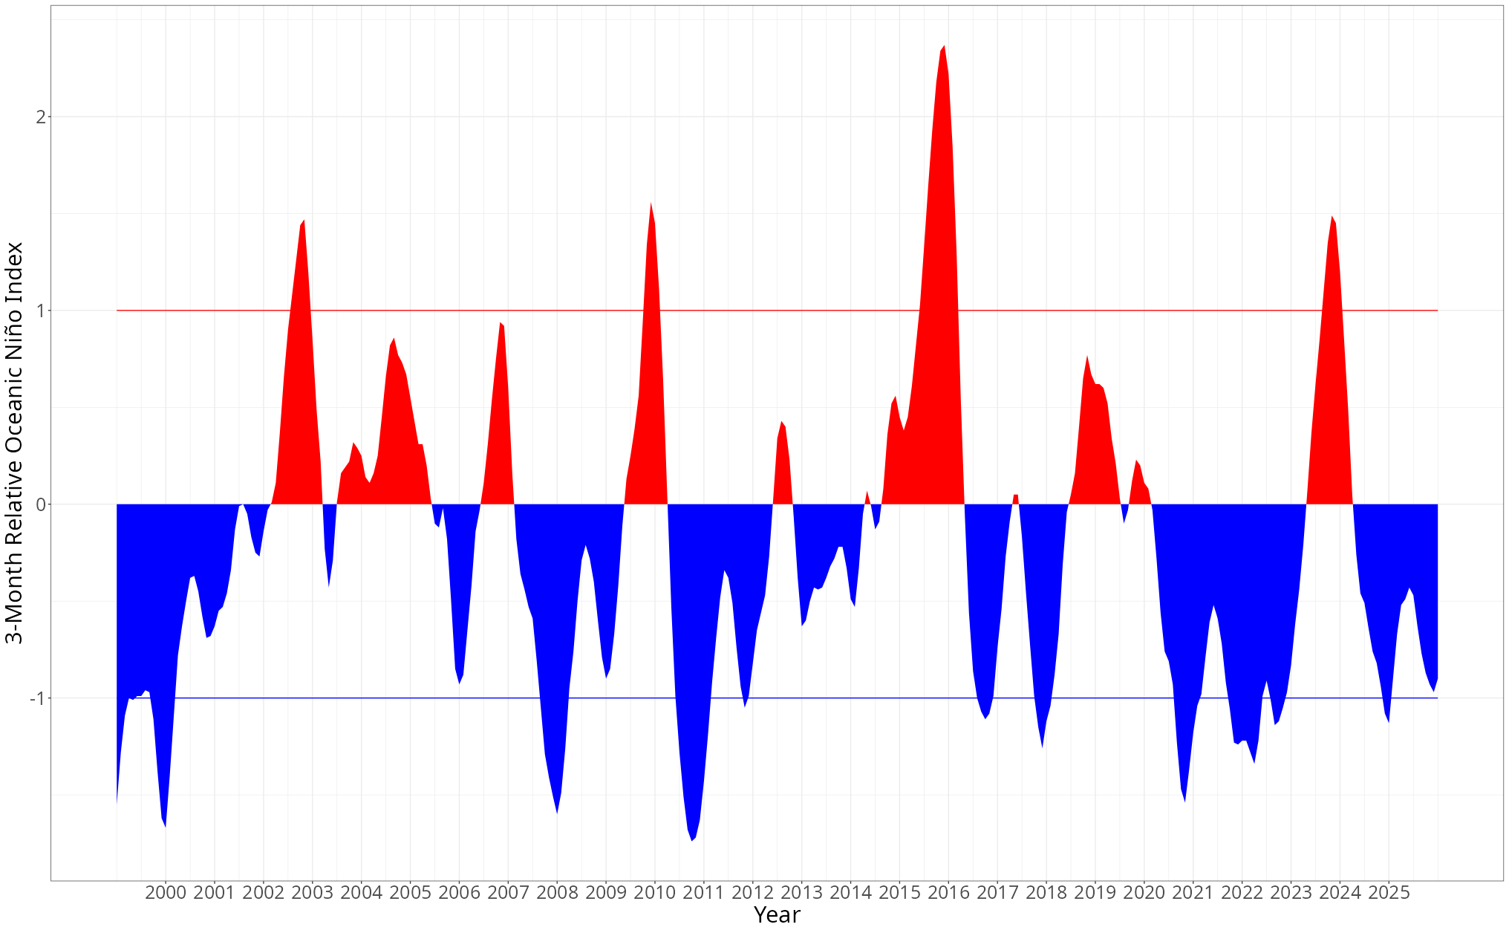
Figure EN Timeline of El Niño and La Niña events over time. Indices that exceed the red intercept line (y = 1) indicate periods of El Niño, and indices that exceed the blue intercept line (y = -1) indicate periods of La Niña
The precipitation changes that were observed as a baseline trend showed no particular pattern over time but were influenced by the ENSO events as stated previously. With El Niño periods being characterised by decreased precipitation. The environment of the Cape Floristic Region is expected to experience more frequent and intense droughts from the effects of climate change as it progresses (Midgley et al., 2003; Hannah et al., 2005), and Southern Africa in general is also expected to become increasingly more arid from climate change in general (Munday et al., 2025). These projected changes compounded with more intense and frequent ENSO events (Wang et al., 2019) could result in extreme levels of drought and precipitation loss in the CFR. Effects of climate change combined with extreme climate phenomena means that the insect decline currently observed in this environment could become progress (Sharp et al., 2025) due to all of the direct and indirect effects.

Current limitations and future considerations
In past studies that examined how the functional groups that are made up of Tenebrionidae and Carabidae interact with their environment in arid landscapes, local vegetation biomass and vegetation species richness were determined to be two important factors that explained the diversity and abundance of the beetles (Liu et al., 2016). These two environmental variables were not measured in this study. Therefore a great portion of possible variation that could have been explained by those might be unrepresented in the final results. Identifying the vegetation present within sampling locations could also provide evidence that the host-plant driven insect distributions that have been described in past studies also apply to this transect (Berzitis et al., 2014; Wilson et al., 2021; Gaona et al., 2025).
The Zophosis gracilicornis, despite being the most abundant beetle in this environment, is not biologically described in terms of its phenology or ecology. Knowing whether it has a generalist or specialist diet, how and when it reproduces, or its habitat choices, would help in explaining its extreme loss of abundance better. Currently even though RDA shows that it is negatively affected by increasingly extreme maximum air and ground temperatures, along with sun intensity, it is not clear what effect this has on the organism itself. The increased temperatures could be resulting in an exceeding of thermal limits, or a reaction with regards to dessication from increased heat. Other studies have proposed that certain species may be responsive to external biotic triggers such as vegetation flowering and leaf flushes in order to advance through their own life stages (Basset, 2003). This suggests that the observed changes in abundance in the beetle sampling could be due to the peak abundance and periods of activity for this species might have shifted temporally due to changing vegetation characteristics from changing environmental factors (Grimbacher and Stork, 2009).
The beetles in the original study were also identified to morphospecies and then to only family level (Botes, McGeoch and Chown, 2007). Gaining access to and finding the original samples of the study was not entirely possible. This meant that the historical comparisons had to be limited to the three species that were extremely abundant and also easily identifiable in the current samples without much difficulty. Not being able to consider the entire sampled species pool meant that the historical comparisons were not able to consider diversity and could only compare abundance. Being able to access and identify the historical sampled would allow for diversity comparisons to improve the explanatory extent of this study greatly.
With regard to the topic of insect decline, there is evidence that there may be some level of declining abundance of beetles that has occurred in the previous 20 years. However most of this decline currently seems to be as a result of one specific prolific species (Zophosis gracilicornis) losing 66% of their abundance. Currently, there can not be be any conclusive statement made regarding whether or not there is biodiversity decline occurring in conjunction with the abundance decline. A definitive conclusion on whether the beetle populations of the Cederberg are declining can be determined if the limitations mentioned in this study are addressed and then re-analysed. The vegetation in the sampling sites need to be recorded in more detail, including species of vegetation present, biomass, and diversity of vegetation. Additionally, the beetles that were sampled in the October 2002 and October 2003 samples that were not identified to species level would need to be identified fully so that direct species diversity and assemblage comparisons can be made between historical and current data. Finally, the sampling and identification of beetles could be expanded to include other beetle families aside from the three that are already being considered, in order to get a better knowledge base of the order as a whole.

References
Adams, J. (2010) ‘Microclimates and vegetation’, in J. Adams, Vegetation—Climate Interaction. Berlin, Heidelberg: Springer Berlin Heidelberg, pp. 97–119. DOI: https://doi.org/10.1007/978-3-642-00881-8_4.
Barratt, B.I.P., Derraik, J.G.B., Rufaut, C.G., Goodman, A.J. and Dickinson, K.J.M. (2003) ‘Morphospecies as a substitute for Coleoptera species identification, and the value of experience in improving accuracy’, Journal of the Royal Society of New Zealand, 33(2), pp. 583–590. DOI: https://doi.org/10.1080/03014223.2003.9517746.
Basset, Y. (ed.) (2003) Arthropods of tropical forests: spatio-temporal dynamics and resource use in the canopy. Cambridge, U.K. ; New York: Cambridge University Press.
Bates, D., Mächler, M., Bolker, B. and Walker, S. (2015) ‘Fitting Linear Mixed-Effects Models Using lme4’, Journal of Statistical Software, 67(1), pp. 1–48. DOI: https://doi.org/10.18637/jss.v067.i01.
Berzitis, E.A., Minigan, J.N., Hallett, R.H. and Newman, J.A. (2014) ‘Climate and host plant availability impact the future distribution of the bean leaf beetle (Cerotoma trifurcata)’, Global Change Biology, 20(9), pp. 2778–2792. DOI: https://doi.org/10.1111/gcb.12557.
Bishop, T.R. and Robertson, M.P. (2024) ‘Mountain habitats for insect conservation’, Routledge Handbook of Insect Conservation. Routledge.
Botes, A., McGeoch, M.A. and Chown, S.L. (2007) ‘Ground-dwelling beetle assemblages in the northern Cape Floristic Region: Patterns, correlates and implications’, Austral Ecology, 32(2), pp. 210–224. DOI: https://doi.org/10.1111/j.1442-9993.2007.01681.x.
Botes, A., McGeoch, M.A., Robertson, H.G., Niekerk, A., Davids, H.P. and Chown, S.L. (2006) ‘Ants, altitude and change in the northern Cape Floristic Region’, Journal of Biogeography, 33(1), pp. 71–90. DOI: https://doi.org/10.1111/j.1365-2699.2005.01336.x.
Boutaud, E., Nolte, D., Harry, I., Assmann, T. and Drees, C. (2022) ‘Conservation value of semi-open habitats for ground beetles (Coleoptera: Carabidae, Cicindelidae) in Central Europe’, Biodiversity and Conservation, 31(5–6), pp. 1469–1489. DOI: https://doi.org/10.1007/s10531-022-02402-z.
Brooks, D.R., Bater, J.E., Clark, S.J., Monteith, D.T., Andrews, C., Corbett, S.J., Beaumont, D.A. and Chapman, J.W. (2012) ‘Large carabid beetle declines in a United Kingdom monitoring network increases evidence for a widespread loss in insect biodiversity’, Journal of Applied Ecology, 49(5), pp. 1009–1019. DOI: https://doi.org/10.1111/j.1365-2664.2012.02194.x.
Byeon, U.-J., Lee, S.-I., Park, S.-J., Kim, A.-Y. and Park, J.-S. (2022) ‘Winter sampling and seasonal variation in litter-dwelling beetle assemblages using a sifting method’, The Canadian Entomologist, 154(1), p. e6. DOI: https://doi.org/10.4039/tce.2021.54.
Cai, W., Ng, B., Geng, T., Jia, F., Wu, L., Wang, G., Liu, Yu, Gan, B., Yang, K., Santoso, A., Lin, X., Li, Z., Liu, Yi, Yang, Y., Jin, F.-F., Collins, M. and McPhaden, M.J. (2023) ‘Anthropogenic impacts on twentieth-century ENSO variability changes’, Nature Reviews Earth & Environment, 4(6), pp. 407–418. DOI: https://doi.org/10.1038/s43017-023-00427-8.
Calvin, K., Dasgupta, D., Krinner, G., Mukherji, A., Thorne, P.W., Trisos, C., Romero, J., Aldunce, P., Barrett, K., Blanco, G., Cheung, W.W.L., Connors, S., Denton, F., Diongue-Niang, A., Dodman, D., Garschagen, M., Geden, O., Hayward, B., Jones, C., Jotzo, F., Krug, T., Lasco, R., Lee, Y.-Y., Masson-Delmotte, V., Meinshausen, M., Mintenbeck, K., Mokssit, A., Otto, F.E.L., Pathak, M., Pirani, A., Poloczanska, E., Pörtner, H.-O., Revi, A., Roberts, D.C., Roy, J., Ruane, A.C., Skea, J., Shukla, P.R., Slade, R., Slangen, A., Sokona, Y., Sörensson, A.A., Tignor, M., Van Vuuren, D., Wei, Y.-M., Winkler, H., Zhai, P., Zommers, Z., Hourcade, J.-C., Johnson, F.X., Pachauri, S., Simpson, N.P., Singh, C., Thomas, A., Totin, E., Alegría, A., Armour, K., Bednar-Friedl, B., Blok, K., Cissé, G., Dentener, F., Eriksen, S., Fischer, E., Garner, G., Guivarch, C., Haasnoot, M., Hansen, G., Hauser, M., Hawkins, E., Hermans, T., Kopp, R., Leprince-Ringuet, N., Lewis, J., Ley, D., Ludden, C., Niamir, L., Nicholls, Z., Some, S., Szopa, S., Trewin, B., Van Der Wijst, K.-I., Winter, G., Witting, M., Birt, A. and Ha, M. (2023) IPCC, 2023: Climate Change 2023: Synthesis Report. Contribution of Working Groups I, II and III to the Sixth Assessment Report of the Intergovernmental Panel on Climate Change [Core Writing Team, H. Lee and J. Romero (eds.)]. IPCC, Geneva, Switzerland. First. Edited by P. Arias, M. Bustamante, I. Elgizouli, G. Flato, M. Howden, C. Méndez-Vallejo, J.J. Pereira, R. Pichs-Madruga, S.K. Rose, Y. Saheb, R. Sánchez Rodríguez, D. Ürge-Vorsatz, C. Xiao, N. Yassaa, J. Romero, J. Kim, E.F. Haites, Y. Jung, R. Stavins, A. Birt, M. Ha, D.J.A. Orendain, L. Ignon, S. Park, Y. Park, A. Reisinger, D. Cammaramo, A. Fischlin, J.S. Fuglestvedt, G. Hansen, C. Ludden, V. Masson-Delmotte, J.B.R. Matthews, K. Mintenbeck, A. Pirani, E. Poloczanska, N. Leprince-Ringuet, and C. Péan. Intergovernmental Panel on Climate Change (IPCC). DOI: https://doi.org/10.59327/IPCC/AR6-9789291691647.
Cardoso, P., Barton, P.S., Birkhofer, K., Chichorro, F., Deacon, C., Fartmann, T., Fukushima, C.S., Gaigher, R., Habel, J.C., Hallmann, C.A., Hill, M.J., Hochkirch, A., Kwak, M.L., Mammola, S., Ari Noriega, J., Orfinger, A.B., Pedraza, F., Pryke, J.S., Roque, F.O., Settele, J., Simaika, J.P., Stork, N.E., Suhling, F., Vorster, C. and Samways, M.J. (2020) ‘Scientists’ warning to humanity on insect extinctions’, Biological Conservation, 242, p. 108426. DOI: https://doi.org/10.1016/j.biocon.2020.108426.
Carpaneto, G., M. and Fattorini, S. (2002) ‘Flightlessness in psammophilous beetles inhabiting a Mediterranean coastal area: ecological and biogeographical implications’, Biogeographia – The Journal of Integrative Biogeography, 23. DOI: https://doi.org/10.21426/B6110050.
Cheli, G.H., Bosco, T. and Flores, G.E. (2022) ‘The role of Nyctelia circumundata (Coleoptera: Tenebrionidae) on litter fragmentation processes and soil fertility in northeastern arid patagonia’, Geoderma, 415, p. 115770. DOI: https://doi.org/10.1016/j.geoderma.2022.115770.
Cheli, G.H., Carrara, R., Bandieri, L. and Flores, G.E. (2021) ‘Distribution and environmental determinants of darkling beetles assemblages (Coleoptera: Tenebrionidae) in Península Valdés (Argentinean Patagonia)’, Anais da Academia Brasileira de Ciências, 93(3), p. e20201282. DOI: https://doi.org/10.1590/0001-3765202120201282.
Chen, I., Hill, J.K., Shiu, H., Holloway, J.D., Benedick, S., Chey, V.K., Barlow, H.S. and Thomas, C.D. (2011) ‘Asymmetric boundary shifts of tropical montane Lepidoptera over four decades of climate warming’, Global Ecology and Biogeography, 20(1), pp. 34–45. DOI: https://doi.org/10.1111/j.1466-8238.2010.00594.x.
Dokumentov, A. and Hyndman, R.J. (2022) ‘STR: Seasonal-Trend Decomposition Using Regression’, INFORMS Journal on Data Science, 1(1), pp. 50–62. DOI: https://doi.org/10.1287/ijds.2021.0004.
Duan, M., Liu, Y., Yu, Z., Li, L., Wang, C. and Axmacher, J.C. (2016) ‘Environmental factors acting at multiple scales determine assemblages of insects and plants in agricultural mountain landscapes of northern China’, Agriculture, Ecosystems & Environment, 224, pp. 86–94. DOI: https://doi.org/10.1016/j.agee.2016.03.025.
Fattorini, S. (2023) ‘Adaptations of tenebrionid beetles to Mediterranean sand dune environments and the impact of climate change (Coleoptera: Tenebrionidae)’, Fragmenta entomologica, p. Vol. 55 No. 1 (2023). DOI: https://doi.org/10.13133/2284-4880/1496.
Forister, M.L., Pelton, E.M. and Black, S.H. (2019) ‘Declines in insect abundance and diversity: We know enough to act now’, Conservation Science and Practice, 1(8), p. e80. DOI: https://doi.org/10.1111/csp2.80.
Gaona, F.P., Delabye, S., Potocký, P., Govorov, V., Čuda, J., Foxcroft, L.C., Garlacz, R., Hejda, M., MacFadyen, S., Pyrcz, T., Pyšková, K., Sedláček, O., Storch, D., Pyšek, P. and Tropek, R. (2025) ‘Climate-Driven Vegetation Characteristics Shape Phytophagous and Carnivorous Insect Diversity in South African Savannahs’, Journal of Biogeography, 52(4), p. e15076. DOI: https://doi.org/10.1111/jbi.15076.
Gonçalves, F., Carlos, C., Crespo, L., Zina, V., Oliveira, A., Salvação, J., Pereira, J.A. and Torres, L. (2021) ‘Soil Arthropods in the Douro Demarcated Region Vineyards: General Characteristics and Ecosystem Services Provided’, Sustainability, 13(14), p. 7837. DOI: https://doi.org/10.3390/su13147837.
Grimbacher, P.S. and Stork, N.E. (2009) ‘Seasonality of a Diverse Beetle Assemblage Inhabiting Lowland Tropical Rain Forest in Australia’, Biotropica, 41(3), pp. 328–337. DOI: https://doi.org/10.1111/j.1744-7429.2008.00477.x.
Hagen, M. and Azevedo, A. (2024) ‘El Niño-Southern Oscillation (ENSO) Variations and Climate Changes Worldwide’, Atmospheric and Climate Sciences, 14(02), pp. 233–249. DOI: https://doi.org/10.4236/acs.2024.142015.
Hannah, L., Midgley, G., Hughes, G. and Bomhard, B. (2005) ‘The View from the Cape: Extinction Risk, Protected Areas, and Climate Change’, BioScience, 55(3), pp. 231–242. DOI: https://doi.org/10.1641/0006-3568(2005)055%255B0231:TVFTCE%255D2.0.CO;2.
Harte, J., Torn, M.S., Chang, F.-R., Feifarek, B., Kinzig, A.P., Shaw, R. and Shen, K. (1995) ‘Global Warming and Soil Microclimate: Results from a Meadow-Warming Experiment’, Ecological Applications, 5(1), pp. 132–150. DOI: https://doi.org/10.2307/1942058.
Harvey, J.A. and Malcicka, M. (2015) ‘Climate Change, Range Shifts and Multitrophic Interactions’, Biodiversity in Ecosystems - Linking Structure and Function. IntechOpen. DOI: https://doi.org/10.5772/59269.
Harvey, J.A., Tougeron, K., Gols, R., Heinen, R., Abarca, M., Abram, P.K., Basset, Y., Berg, M., Boggs, C., Brodeur, J., Cardoso, P., de Boer, J.G., De Snoo, G.R., Deacon, C., Dell, J.E., Desneux, N., Dillon, M.E., Duffy, G.A., Dyer, L.A., Ellers, J., Espíndola, A., Fordyce, J., Forister, M.L., Fukushima, C., Gage, M.J.G., García-Robledo, C., Gely, C., Gobbi, M., Hallmann, C., Hance, T., Harte, J., Hochkirch, A., Hof, C., Hoffmann, A.A., Kingsolver, J.G., Lamarre, G.P.A., Laurance, W.F., Lavandero, B., Leather, S.R., Lehmann, P., Le Lann, C., López-Uribe, M.M., Ma, C.-S., Ma, G., Moiroux, J., Monticelli, L., Nice, C., Ode, P.J., Pincebourde, S., Ripple, W.J., Rowe, M., Samways, M.J., Sentis, A., Shah, A.A., Stork, N., Terblanche, J.S., Thakur, M.P., Thomas, M.B., Tylianakis, J.M., Van Baaren, J., Van de Pol, M., Van der Putten, W.H., Van Dyck, H., Verberk, W.C.E.P., Wagner, D.L., Weisser, W.W., Wetzel, W.C., Woods, H.A., Wyckhuys, K.A.G. and Chown, S.L. (2023) ‘Scientists’ warning on climate change and insects’, Ecological Monographs, 93(1), p. e1553. DOI: https://doi.org/10.1002/ecm.1553.
Hersbach, H., Bell, B., Berrisford, P., Hirahara, S., Horányi, A., Muñoz‐Sabater, J., Nicolas, J., Peubey, C., Radu, R., Schepers, D., Simmons, A., Soci, C., Abdalla, S., Abellan, X., Balsamo, G., Bechtold, P., Biavati, G., Bidlot, J., Bonavita, M., De Chiara, G., Dahlgren, P., Dee, D., Diamantakis, M., Dragani, R., Flemming, J., Forbes, R., Fuentes, M., Geer, A., Haimberger, L., Healy, S., Hogan, R.J., Hólm, E., Janisková, M., Keeley, S., Laloyaux, P., Lopez, P., Lupu, C., Radnoti, G., De Rosnay, P., Rozum, I., Vamborg, F., Villaume, S. and Thépaut, J. (2020) ‘The ERA5 global reanalysis’, Quarterly Journal of the Royal Meteorological Society, 146(730), pp. 1999–2049. DOI: https://doi.org/10.1002/qj.3803.
Hodek, I. (2012) ‘Adult Diapause in Coleoptera’, Psyche: A Journal of Entomology, 2012, pp. 1–10. DOI: https://doi.org/10.1155/2012/249081.
Hodkinson, I.D. (2005) ‘Terrestrial insects along elevation gradients: species and community responses to altitude’, Biological Reviews, 80(3), pp. 489–513. DOI: https://doi.org/10.1017/S1464793105006767.
Holland, J.M. and Luff, M.L. (2000) ‘The Effects of Agricultural Practices on Carabidae in Temperate Agroecosystems’, Integrated Pest Management Reviews, 5(2), pp. 109–129. DOI: https://doi.org/10.1023/A:1009619309424.
Homburg, K., Brandt, P., Drees, C. and Assmann, T. (2014) ‘Evolutionarily significant units in a flightless ground beetle show different climate niches and high extinction risk due to climate change’, Journal of Insect Conservation, 18(5), pp. 781–790. DOI: https://doi.org/10.1007/s10841-014-9685-x.
Klinges, D.H., Duffy, J.P., Kearney, M.R. and Maclean, I.M.D. (2022) ‘mcera5 : Driving microclimate models with ERA5 global gridded climate data’, Methods in Ecology and Evolution, 13(7), pp. 1402–1411. DOI: https://doi.org/10.1111/2041-210X.13877.
Kremen, C. and Chaplin-Kramer, R. (2007) ‘Insects as Providers of Ecosystem Services: Crop Pollination and Pest Control’, Insect Conservation Biology. UK: CAB International, pp. 349–382. DOI: https://doi.org/10.1079/9781845932541.0000.
Lenoir, J., Gégout, J.C., Marquet, P.A., de Ruffray, P. and Brisse, H. (2008) ‘A Significant Upward Shift in Plant Species Optimum Elevation During the 20th Century’, Science, 320(5884), pp. 1768–1771. DOI: https://doi.org/10.1126/science.1156831.
Liu, J.-L., Li, F.-R., Sun, T.-S., Ma, L.-F., Liu, L.-L. and Yang, K. (2016) ‘Interactive effects of vegetation and soil determine the composition and diversity of carabid and tenebrionid functional groups in an arid ecosystem’, Journal of Arid Environments, 128, pp. 80–90. DOI: https://doi.org/10.1016/j.jaridenv.2016.01.009.
Liu, X., Wang, H., He, D., Wang, X. and Bai, M. (2021) ‘The Modeling and Forecasting of Carabid Beetle Distribution in Northwestern China’, Insects, 12(2), p. 168. DOI: https://doi.org/10.3390/insects12020168.
Liu, X., Wang, H., Wang, X., Bai, M. and He, D. (2021) ‘Driving factors and their interactions of carabid beetle distribution based on the geographical detector method’, Ecological Indicators, 133, p. 108393. DOI: https://doi.org/10.1016/j.ecolind.2021.108393.
Losey, J.E. and Vaughan, M. (2006) ‘The Economic Value of Ecological Services Provided by Insects’, BioScience, 56(4), p. 311. DOI: https://doi.org/10.1641/0006-3568(2006)56%255B311:TEVOES%255D2.0.CO;2.
Lövei, G.L. and Sunderland, K.D. (1996) ‘Ecology and Behavior of Ground Beetles (Coleoptera: Carabidae)’, Annual Review of Entomology, 41(1), pp. 231–256. DOI: https://doi.org/10.1146/annurev.en.41.010196.001311.
Maclean, I. (2025) micropoint: Below or within canopy point microclimate modelling with R. URL: https://github.com/ilyamaclean/micropoint.
Makwela, M.M., Slotow, R. and Munyai, T.C. (2023) ‘Carabid Beetles (Coleoptera) as Indicators of Sustainability in Agroecosystems: A Systematic Review’, Sustainability, 15(5), p. 3936. DOI: https://doi.org/10.3390/su15053936.
McCain, C.M. and Garfinkel, C.F. (2021) ‘Climate change and elevational range shifts in insects’, Current Opinion in Insect Science, 47, pp. 111–118. DOI: https://doi.org/10.1016/j.cois.2021.06.003.
Menéndez, R., González-Megías, A., Jay-Robert, P. and Marquéz-Ferrando, R. (2014) ‘Climate change and elevational range shifts: evidence from dung beetles in two European mountain ranges’, Global Ecology and Biogeography, 23(6), pp. 646–657. DOI: https://doi.org/10.1111/geb.12142.
Midgley, G.F., Hannah, L., Millar, D., Thuiller, W. and Booth, A. (2003) ‘Developing regional and species-level assessments of climate change impacts on biodiversity in the Cape Floristic Region’, Biological Conservation, 112(1), pp. 87–97. DOI: https://doi.org/10.1016/S0006-3207(02)00414-7.
Mordkovich, V.G. and Afanas’ev, N.A. (1980) ‘Transformation of steppe litter by darkling-beetles (Coleoptera, Tenebrionidae).’, Ekologiya, 11(3), pp. 175–180.
Mucina, L. and Rutherford, M.C. (eds) (2006) The vegetation of South Africa, Lesotho and Swaziland. Pretoria: South African National Biodiversity Institute (Strelitzia, 19).
Munday, C., Washington, R., Engelstaedter, S., Zilli, M., Harbord, S., Knight, C., Attwood, K. and Hart, N. (2025) ‘Southern African Climate Change: Processes, Models, and Projections’, WIREs Climate Change, 16(5), p. e70025. DOI: https://doi.org/10.1002/wcc.70025.
Musthafa, M.M., Abdullah, F., Martínez-Falcón, A.P. and de Bruyn, M. (2021) ‘How mountains and elevations shape the spatial distribution of beetles in Peninsular Malaysia’, Scientific Reports, 11(1), p. 5791. DOI: https://doi.org/10.1038/s41598-021-84965-5.
NASA JPL (2013) ‘NASA Shuttle Radar Topography Mission Global 1 arc second’. NASA Land Processes Distributed Active Archive Center. DOI: https://doi.org/10.5067/MEASURES/SRTM/SRTMGL1.003.
National Oceanic and Atmospheric Administration (2026) National Oceanic and Atmospheric Administration, Nation Weather Service Climate Prediction Center. URL: https://www.cpc.ncep.noaa.gov/products/analysis_monitoring/ensostuff/ONI_v5.php.
Ndozi, M.H., Gohole, L. and Mapaure, I. (2025) ‘Seasonal Variations in Dung Beetle (Scarabaeidae: Scarabaeinae) Assemblage in Wildlife and Wildlife–Livestock Systems in North‐Eastern Namibia’, African Journal of Ecology, 63(6), p. e70083. DOI: https://doi.org/10.1111/aje.70083.
Niemelä, J. (1993) ‘Interspecific Competition in Ground-Beetle Assemblages (Carabidae): What Have We Learned?’, Oikos, 66(2), p. 325. DOI: https://doi.org/10.2307/3544821.
Oberhauser, K. and Guiney, M. (2009) ‘Insects as flagship conservation species’, Terrestrial Arthropod Reviews, 1(2), pp. 111–123. DOI: https://doi.org/10.1163/187498308X414733.
Pebesma, E. and Bivand, R. (2023) Spatial Data Science: With Applications in R. 1st edn. New York: Chapman and Hall/CRC. DOI: https://doi.org/10.1201/9780429459016.
Picker, M., Griffiths, C.L. and Weaving, A. (2019) Field guide to insects of South Africa. Third edition. Cape Town, South Africa: Struik Nature.
Pinheiro, F., Diniz, I.R., Coelho, D. and Bandeira, M.P.S. (2002) ‘Seasonal pattern of insect abundance in the Brazilian cerrado’, Austral Ecology, 27(2), pp. 132–136. DOI: https://doi.org/10.1046/j.1442-9993.2002.01165.x.
R Core Team (2026) R: A Language and Environment for Statistical Computing. Vienna, Austria: R Foundation for Statistical Computing. URL: https://www.R-project.org/.
Ramírez-Hernández, A., Micó, E. and Galante, E. (2014) ‘Temporal variation in saproxylic beetle assemblages in a Mediterranean ecosystem’, Journal of Insect Conservation, 18(5), pp. 993–1007. DOI: https://doi.org/10.1007/s10841-014-9706-9.
Ren, J., Zhao, W., He, Z., Wang, Y., Feng, Y., Niu, Y., Xin, W., Pan, C. and Liu, J. (2025) ‘Spatiotemporal variations of tenebrionid beetles (Coleoptera: Tenebrionidae) in the Gobi desert, Northwest China’, Journal of Arid Land, 17(1), pp. 112–129. DOI: https://doi.org/10.1007/s40333-025-0001-2.
Röder, J., Detsch, F., Otte, I., Appelhans, T., Nauss, T., Peters, M.K. and Brandl, R. (2017) ‘Heterogeneous patterns of abundance of epigeic arthropod taxa along a major elevation gradient’, Biotropica, 49(2), pp. 217–228. DOI: https://doi.org/10.1111/btp.12403.
Rudolf, V.H.W. and Roman, A. (2018) ‘Trophic structure alters consequences of environmental warming’, Oikos, 127(11), pp. 1646–1656. DOI: https://doi.org/10.1111/oik.05535.
Rutten, G., Ensslin, A., Hemp, A. and Fischer, M. (2015) ‘Vertical and Horizontal Vegetation Structure across Natural and Modified Habitat Types at Mount Kilimanjaro’, PLOS ONE. Edited by L.C.R. Silva, 10(9), p. e0138822. DOI: https://doi.org/10.1371/journal.pone.0138822.
Samways, M. (2010) ‘Impacts of extreme weather and climate change on South African dragonflies’, BioRisk, 5, pp. 73–84. DOI: https://doi.org/10.3897/biorisk.5.843.
Sánchez-Bayo, F. and Wyckhuys, K.A.G. (2019) ‘Worldwide decline of the entomofauna: A review of its drivers’, Biological Conservation, 232, pp. 8–27. DOI: https://doi.org/10.1016/j.biocon.2019.01.020.
Santos, A. (2002) ‘Habitat selection and assemblage structure of darkling beetles (Col. Tenebrionidae) along environmental gradients on the island of Tenerife (Canary Islands)’, Journal of Arid Environments, 52(1), pp. 63–85. DOI: https://doi.org/10.1016/S0140-1963(01)90927-9.
Scholtz, C.H. and Holm, E. (eds) (1985) Insects of southern Africa. Durban ; Stoneham, MA: Butterworths.
Sharp, A.C., Boyle, M.J.W., Bonebrake, T.C., Guo, Y., Kitching, R.L., Stork, N.E., Zeng, X. and Ashton, L.A. (2025) ‘Stronger El Niños reduce tropical forest arthropod diversity and function’, Nature, 645(8082), pp. 946–951. DOI: https://doi.org/10.1038/s41586-025-09351-x.
Soh, M.C.K., Mitchell, N.J., Ridley, A.R., Butler, C.W., Puan, C.L. and Peh, K.S.-H. (2019) ‘Impacts of Habitat Degradation on Tropical Montane Biodiversity and Ecosystem Services: A Systematic Map for Identifying Future Research Priorities’, Frontiers in Forests and Global Change, 2, p. 83. DOI: https://doi.org/10.3389/ffgc.2019.00083.
Srygley, R.B., Dudley, R., Oliveira, E.G., Aizprúa, R., Pelaez, N.Z. and Riveros, A.J. (2010) ‘El Niño and dry season rainfall influence hostplant phenology and an annual butterfly migration from Neotropical wet to dry forests’, Global Change Biology, 16(3), pp. 936–945. DOI: https://doi.org/10.1111/j.1365-2486.2009.01986.x.
Trichard, A., Ricci, B., Ducourtieux, C. and Petit, S. (2014) ‘The spatio-temporal distribution of weed seed predation differs between conservation agriculture and conventional tillage’, Agriculture, Ecosystems & Environment, 188, pp. 40–47. DOI: https://doi.org/10.1016/j.agee.2014.01.031.
Tsafack, N., Xie, Y., Wang, X. and Fattorini, S. (2019) ‘Influence of Climate and Local Habitat Characteristics on Carabid Beetle Abundance and Diversity in Northern Chinese Steppes’, Insects, 11(1), p. 19. DOI: https://doi.org/10.3390/insects11010019.
Tyszecka, K., Zając, K. and Kadej, M. (2025) ‘Winter and summer conditions affect the mountain population of Carabus variolosus, a ground beetle of European conservation concern’, Science of The Total Environment, 972, p. 179149. DOI: https://doi.org/10.1016/j.scitotenv.2025.179149.
Vetaas, O.R. (2021) ‘Mountain biodiversity and elevational gradients’, Frontiers of Biogeography, 13(3). DOI: https://doi.org/10.21425/F5FBG54146.
Vodka, Š. and Cizek, L. (2013) ‘The effects of edge-interior and understorey-canopy gradients on the distribution of saproxylic beetles in a temperate lowland forest’, Forest Ecology and Management, 304, pp. 33–41. DOI: https://doi.org/10.1016/j.foreco.2013.04.007.
Wang, B., Luo, X., Yang, Y.-M., Sun, W., Cane, M.A., Cai, W., Yeh, S.-W. and Liu, J. (2019) ‘Historical change of El Niño properties sheds light on future changes of extreme El Niño’, Proceedings of the National Academy of Sciences, 116(45), pp. 22512–22517. DOI: https://doi.org/10.1073/pnas.1911130116.
Wang, Xiaowei, Müller, J., An, L., Ji, L., Liu, Y., Wang, Xugao and Hao, Z. (2014) ‘Intra-annual variations in abundance and species composition of carabid beetles in a temperate forest in Northeast China’, Journal of Insect Conservation, 18(1), pp. 85–98. DOI: https://doi.org/10.1007/s10841-014-9617-9.
Wardhaugh, C.W., Stone, M.J. and Stork, N.E. (2018) ‘Seasonal variation in a diverse beetle assemblage along two elevational gradients in the Australian Wet Tropics’, Scientific Reports, 8(1), p. 8559. DOI: https://doi.org/10.1038/s41598-018-26216-8.
Wilson, J.K., Casajus, N., Hutchinson, R.A., McFarland, K.P., Kerr, J.T., Berteaux, D., Larrivée, M. and Prudic, K.L. (2021) ‘Climate Change and Local Host Availability Drive the Northern Range Boundary in the Rapid Expansion of a Specialist Insect Herbivore, Papilio cresphontes’, Frontiers in Ecology and Evolution, 9. DOI: https://doi.org/10.3389/fevo.2021.579230.
Wilson, R.J., Gutiérrez, D., Gutiérrez, J., Martínez, D., Agudo, R. and Monserrat, V.J. (2005) ‘Changes to the elevational limits and extent of species ranges associated with climate change’, Ecology Letters, 8(11), pp. 1138–1146. DOI: https://doi.org/10.1111/j.1461-0248.2005.00824.x.
Zhu, P., Zhao, T., Meng, Y., Shi, H., Liang, H., Yang, C., Song, F., Zhou, J. and Huang, W. (2025) ‘Comparative and Phylogenetic Analyses of Mitochondrial Genomes in Carabidae (Coleoptera: Adephaga)’, Ecology and Evolution, 15(7), p. e71707. DOI: https://doi.org/10.1002/ece3.71707.
Zu, K., Lenoir, J., Fang, J., Tang, Z., Shen, Z., Ji, C., Zheng, C., Luo, A., Song, W., Zimmermann, N.E., Pellissier, L. and Wang, Z. (2023) ‘Elevational shift in seed plant distributions in China’s mountains over the last 70 years’, Global Ecology and Biogeography, 32(7), pp. 1098–1112. DOI: https://doi.org/10.1111/geb.13692.
Zu, K., Wang, Z., Zhu, X., Lenoir, J., Shrestha, N., Lyu, T., Luo, A., Li, Y., Ji, C., Peng, S., Meng, J. and Zhou, J. (2021) ‘Upward shift and elevational range contractions of subtropical mountain plants in response to climate change’, Science of The Total Environment, 783, p. 146896. DOI: https://doi.org/10.1016/j.scitotenv.2021.146896.

